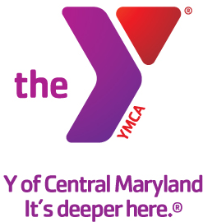

FOR IMMEDIATE RELEASE Media Contact:
March 27, 2015 Leanna Bernhard Profiles, Inc.
410-243-3790
leanna@profilespr.com

Y OF CENTRAL MARYLAND ANNOUNCES NEW VICE PRESIDENT OF MEMBERSHIP DEVELOPMENT
Tammy Sisson will serve as Vice President of Membership Development

(Baltimore, MD) – The Y of Central Maryland is pleased to announce the hiring of Tammy Sisson as Vice President of Membership Development. In this role, Sisson will develop and implement the Y’s membership strategies and activities, while ensuring the very best member experience.

Sisson has been serving in Y membership development roles since 2002. Most recently, she served as Membership Director at the YMCA of Metropolitan Washington, D.C., where she led the membership and marketing department in developing consistent excellence in sales and customer service, while producing and implementing high-quality, relationship-based member engagement strategies.

Sission graduated from the University of Virginia with a Bachelor of Science in Interdisciplinary Studies/Social Science. She now lives in xx.

Our Mission:
The Y of Central Maryland is a charitable organization dedicated to developing the full potential of every individual through programs that build healthy spirit, mind and body for all.

Our Commitment:
At the Y, we are committed to providing family-oriented, affordable, high quality programs.

A cause driven organization with three areas of vital focs:
- For Youth Development: nurturing the potential of every child and teen
- For Healthy Living: improving our community’s health & well-being
- For Social Responsibility: giving back and providing support for our neighbors

The Y is a place for everyone. People of all races, ages, faiths, gender, abilities, backgrounds and incomes are welcome and financial assistance on a sliding scale is available to those who would otherwise be unable to participate.

Our Values:
Caring, Honesty, Respect and Responsibility

More information can be found at www.ymaryland.org.

###

