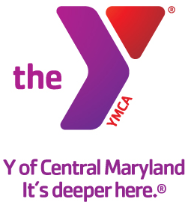

For Immediate Release: MEDIA Contact:
March 24, 2015 Leanna Bernhard
Profiles, Inc.
410-243-3790
leanna@profilespr.com

Y OF CENTRAL MARYLAND HOSTS FAMILY TEA AND PICNIC
Y Family Centers celebrate Mother’s Day with family-fun event

(BALTIMORE)—The Y of Central Maryland will celebrate Mother’s Day with a Family Tea and Picnic at Family Center Ys on Saturday, May 16. Depending on the Center, guests will enjoy a tea or picnic, arts and crafts and more! Event times and activities vary by location, so please contact your local Family Center Y for specific details.
WHAT:
Y Family Tea and Picnic

WHEN:
Saturday, May 16, 2015

WHERE:
Y of Central Maryland Family Centers
Please see locations at: http://ymaryland.org/.

COST:
FREE for Y members
$5 for community members
$10 for community families

INFO:
For more information, please visit www.ymaryland.org or visit your local Family Center Y.

Our Mission:
The Y of Central Maryland is a charitable organization dedicated to developing the full potential of every individual through programs that build healthy spirit, mind and body for all.

Our Commitment:
At the Y, we are committed to providing family-oriented, affordable, high quality programs.

A cause driven organization with three areas of vital focus:
- For Youth Development: nurturing the potential of every child and teen
- For Healthy Living: improving our community’s health & well-being
- For Social Responsibility: giving back and providing support for our neighbors

The Y is a place for everyone. People of all races, ages, faiths, gender, abilities, backgrounds and incomes are welcome and financial assistance on a sliding scale is available to those who would otherwise be unable to participate.

Our Values:
Caring, Honesty, Respect and Responsibility

More information can be found at www.ymaryland.org

###

