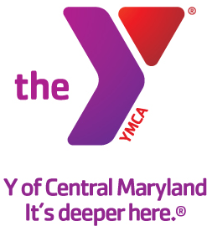

FOR IMMEDIATE RELEASE Media Contact:
July 10, 2015 Leanna Bernhard Profiles, Inc.
410-243-3790
leanna@profilespr.com

Y OF CENTRAL MARYLAND ANNOUNCES NEW BOARD MEMBER
Laura Reagan joins Greater Annapolis Community Leadership Board

(Baltimore, MD) – The Y of Central Maryland is pleased to announce the addition of Laura Reagan, LCSW-C, to the Greater Annapolis Community Leadership Board.

Reagan is a psychotherapist who has her own private practice in Severna Park and is passionate about helping children, adolescents and adults develop meaningful relationships with themselves and important people in their lives. She is a Certified Daring Way™ Facilitator with advanced training in trauma.

Reagan received her Bachelor of Science in sociology from Old Dominion University and her Master of Social Work from University of Maryland. Reagan and her family reside on the Broadneck Peninsula in Anne Arundel County.

Our Mission:
The Y of Central Maryland is a charitable organization dedicated to developing the full potential of every individual through programs that build healthy spirit, mind and body for all.

Our Commitment:
At the Y, we are committed to providing family-oriented, affordable, high quality programs.

A cause driven organization with three areas of vital focus:
- For Youth Development: nurturing the potential of every child and teen
- For Healthy Living: improving our community’s health & well-being
- For Social Responsibility: giving back and providing support for our neighbors

The Y is a place for everyone. People of all races, ages, faiths, gender, abilities, backgrounds and incomes are welcome and financial assistance on a sliding scale is available to those who would otherwise be unable to participate.

Our Values:
Caring, Honesty, Respect and Responsibility

More information can be found at www.ymaryland.org.

###

