MY STAMP COLLECTION
- Create the first three stamps in your stamp collection
- Cut them out
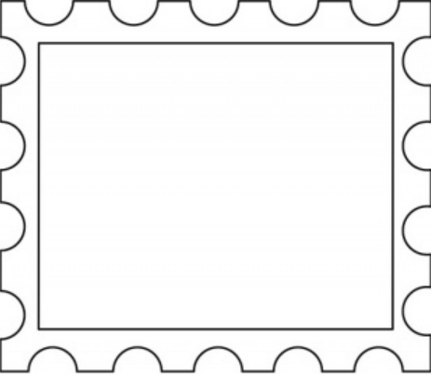
- - - - - - - - - - - - - - - - - - - - - - - - - - - - - - - - - - - - - - - - - -
MY STAMP COLLECTION
- Choose one of the stamps you designed above and paste it on your postcard
- Paste the other two stamps below and create a new stamp for your collection

