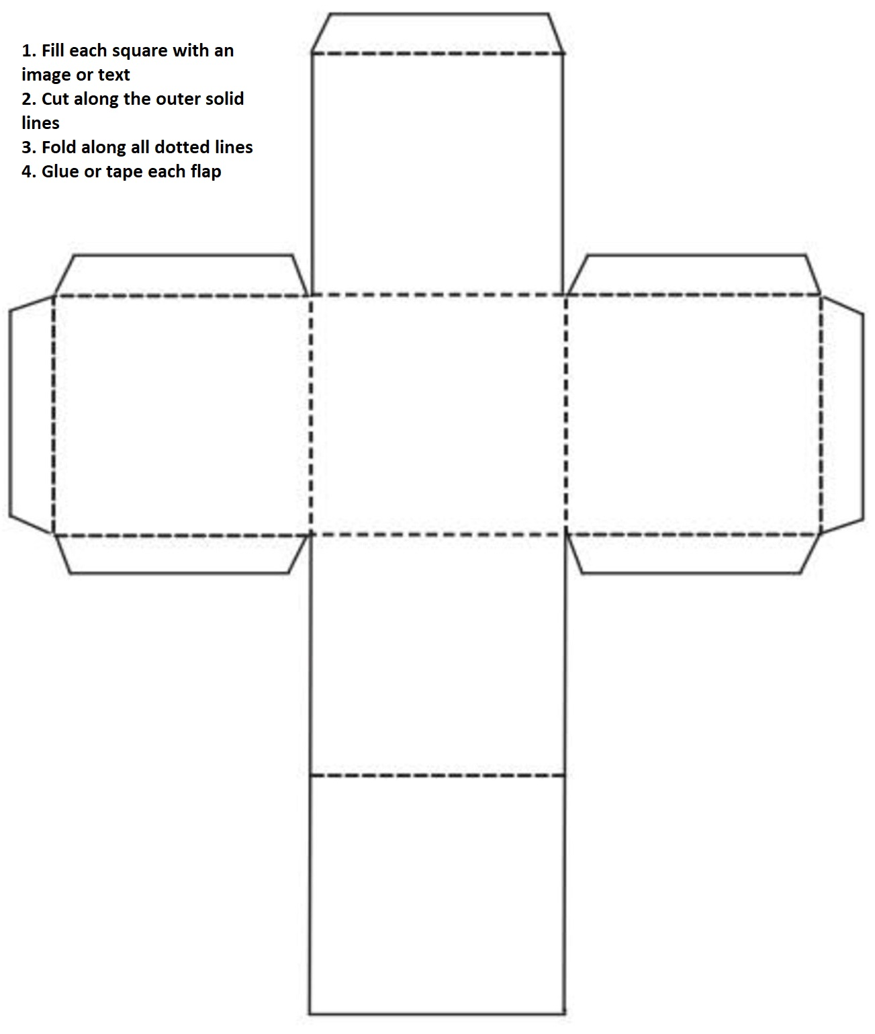
CUSTOMIZE YOUR DICE

