DECODING BRAILLE RIDDLES – Use the braille alphabet to answer these riddles

What do planets like to read?

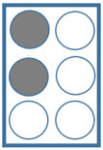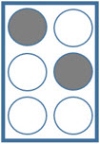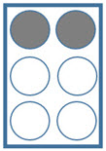

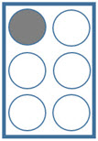

When do astronauts eat their lunch?

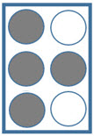

What do space creatures drink in the afternoon?

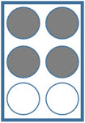

What type of music do planets listen to?



DECODING BRAILLE RIDDLES - ANSWERS

What do planets like to read?



c o m e t b o o k s



When do astronauts eat their lunch?

l a u n c h t i m e



What do space creatures drink in the afternoon?



g r a v i t e a

What type of music do planets listen to?



n e p t u n e s