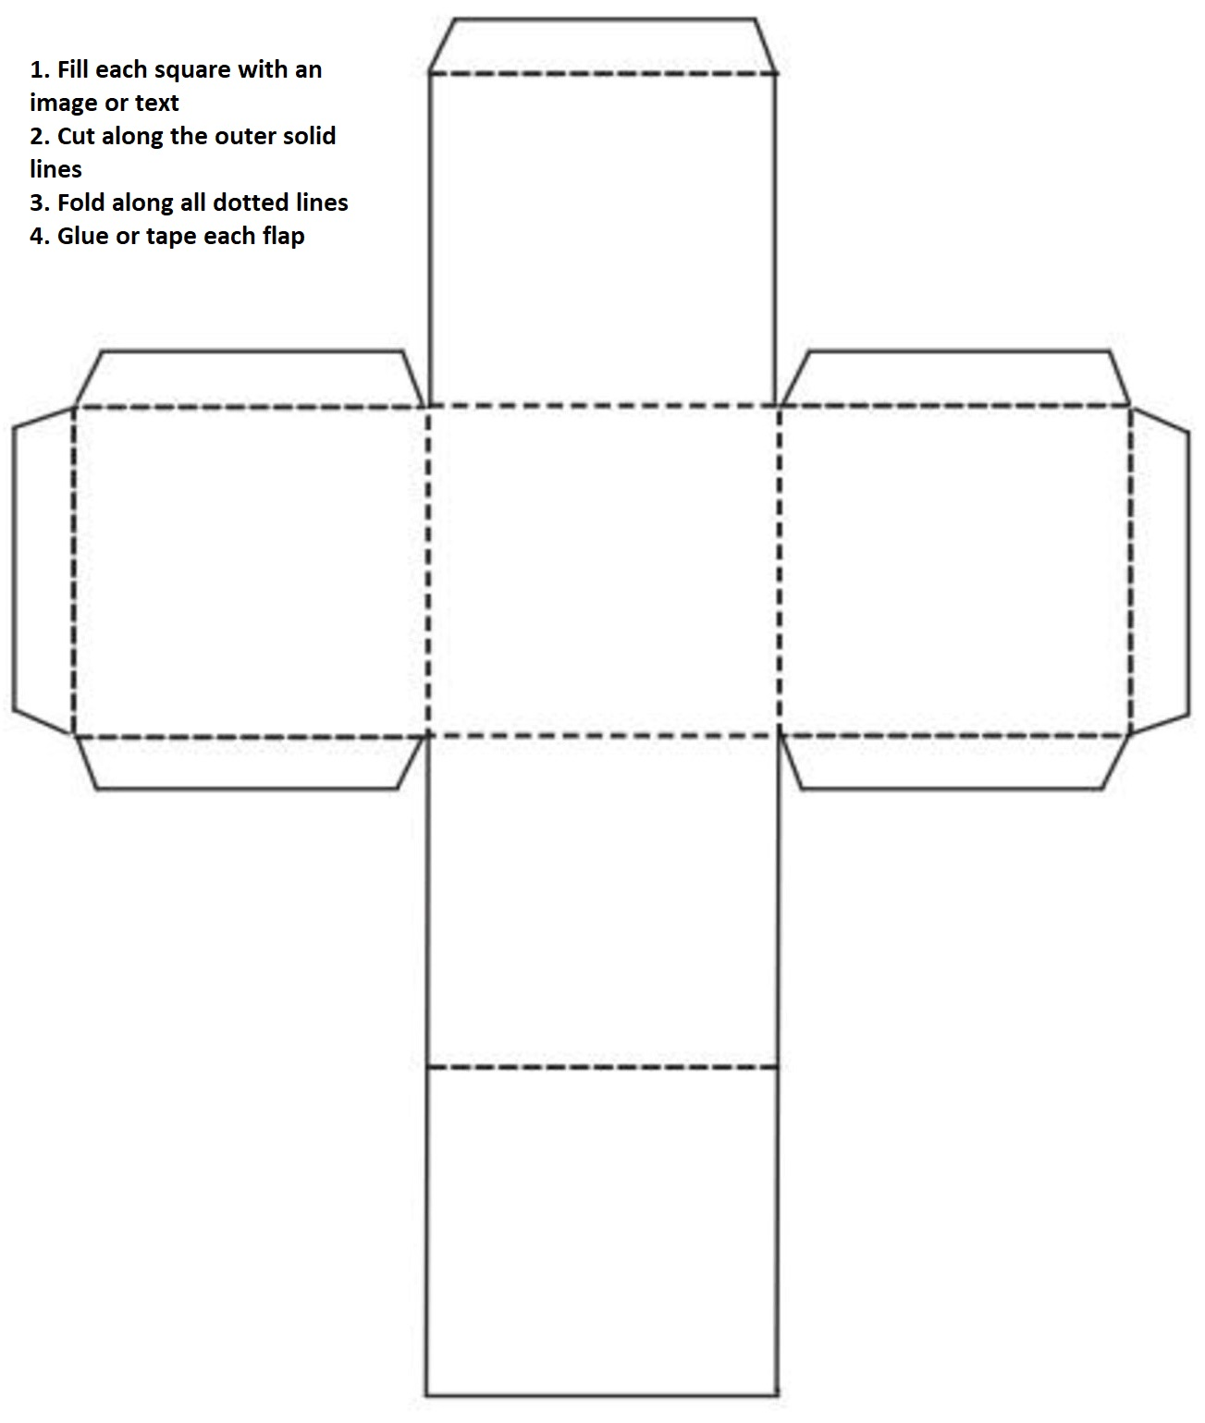**OBJECT DICE EXAMPLE**

**PIZZA**

**BOAT**

**ICE-CREAM CONE**

**MICROPHONE**

**BOOK**

**TACOS**

**SETTING DICE EXAMPLE**

**CHARACTER DICE EXAMPLE**

**BLACKHOLE**

**SPACESHIP**

**SPACE STATION**

**PLUTO**

**PLANET**

**MOON**



**CAT**

**DOG**



**ASTRONAUT**

**BUNNY**

**TURTLE**