CREATE YOUR OWN BRAILLE ALPHABET
To make proper, tactile braille, fill dots with stickers/glue that you can feel with your fingers.
To make simulated braille, you can colour in the dots of the braille cells.
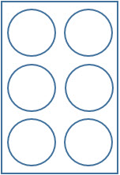
a b c d e f g h i j

k l m n o p q r s t

Braille Cell Braille Pattern
A to J – 1st row: the base letters
K to T – 2nd row: A to J + dot 3
U to Z – 3rd row: K to O + dot 6
W – J + dot 6
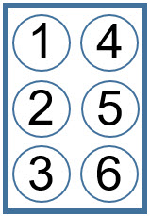
u v x y z w

