SIMULATED BRAILLE ALPHABET – To make simulated braille, you can colour in the dots of the braille cells

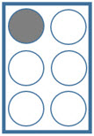 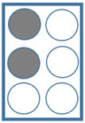 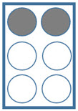 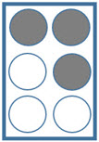 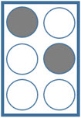 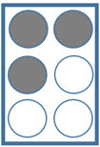 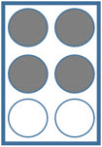 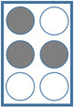 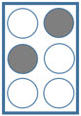 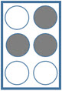

**a b c d e f g h i j**

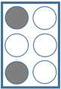 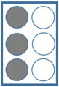 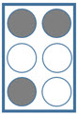 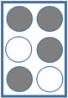 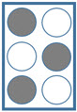 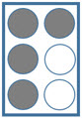 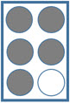 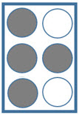 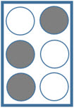 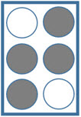

**k l m n o p q r s t**

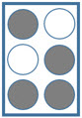

**Braille Cell Braille Pattern**

A to J – 1st row: the base letters

K to T – 2nd row: A to J + dot 3

U to Z – 3rd row: K to O + dot 6

W – J + dot 6

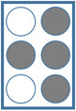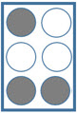 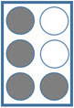 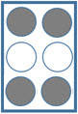 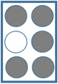

**u v x y z w**