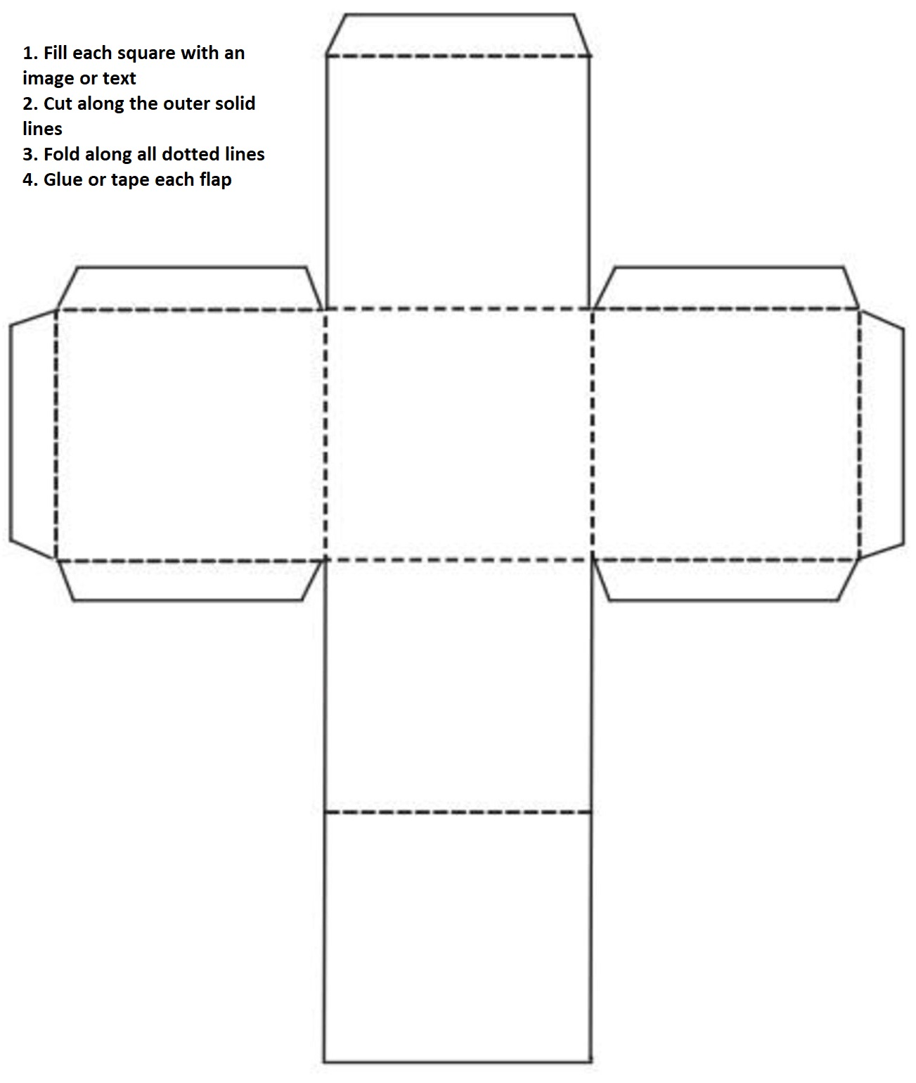
OBJECT DICE EXAMPLE
ROPE
BOOK
WINGS
MAGIC POT
HARP
MAGIC SHOES
SETTING DICE EXAMPLE
CHARACTER DICE EXAMPLE
PYRAMID
CASTLE
CAVE
PLAY-GROUND
KITCHEN
GARDEN

PRINCE
WIZARD
CAT
UNICORN
MONSTER
PRINCESS

