TO THE STARS – BRAILLE ACTIVITY
Colour in and/or add stickers to the correct braille dots to form each letter (e.g., TDSRC - 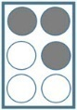 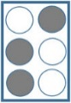 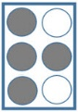 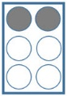 )
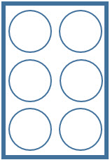
S T A R S G A L A X Y

C O M E T P L A N E T

N I G H T R O C K E T
