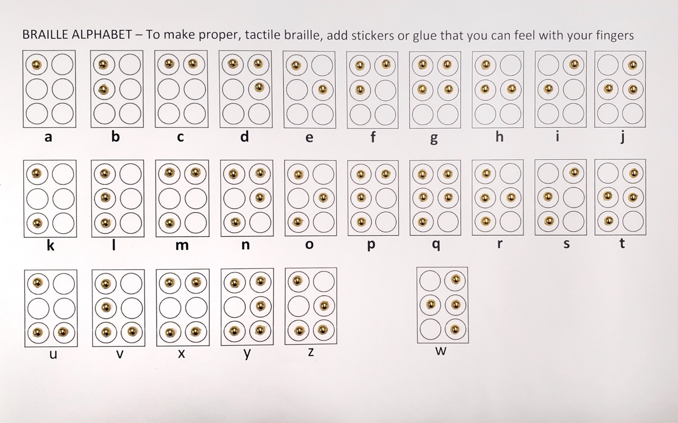

**Braille Cell Braille Pattern**

A to J – 1st row: the base letters

K to T – 2nd row: A to J + dot 3

U to Z – 3rd row: K to O + dot 6

W – J + dot 6