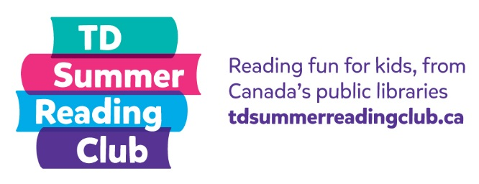
Fiction
Reading Report

My name: __________________________ Age: _______
What I read: ____________________________________
Author: ________________________________________
Rating (Circle one): A = Awesome B = Okay C = Awful
OR My own rating: ______________________________
Answer these questions:
Who was your favourite or least favourite character in the story?

What was the best or worst part of the story?

