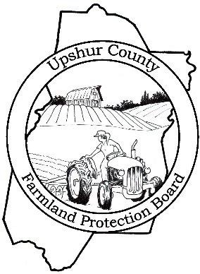

Farmland Protection Board Accepting Applications

Upshur County Farmland Protection Board is currently receiving applications for the purchase and/or donation of conservation easements. Applications must be received by August 1, 2020 to be considered for the upcoming funding cycle.

The purpose of the Farmland Protection Program is to preserve land for farm use, while the farmland remains in the ownership of the landowners. To learn more about this program visit our web page at http://upshur.wvfp.org.

Applications are available at the County Administrator’s Office, located at 91 W Main Street, Suite 101, Buckhannon, WV and the County Assessor’s Office, located at 38 West Main Street, Room 102 Buckhannon, WV. If you would like an application mailed to you, or have any questions, please contact Amy Moloney at 304-667-4877 or e-mail us at upshur@wvfp.org.

