August 8, 2019

The Honorable Joseph Cryan
Legislative Office Building
985 Stuyvesant Ave.
Union, NJ 07083

Dear Senator Cryan,

PeopleForBikes is providing comments on S. 4026, legislation that would require the New Jersey Department of Environmental Protection to post a list of certain chemicals, require manufacturers of children's products to report use of certain chemicals, and prohibit sale or distribution of children's products containing certain chemicals. We are concerned with this legislation’s potential impact on the sale of children’s bicycles in New Jersey.

PeopleForBikes is a national advocacy organization with 1.3 million individual members, including more than 40,000 in New Jersey, that promotes the safe use and enjoyment of bicycles. We are also an industry trade association, with more than 50 bicycle related businesses in New Jersey. Our membership includes some of the largest bicycle manufacturers in the world, many of which have extensive distribution networks in New Jersey.

While we understand the public health concerns related to the use of chemicals in children’s products, support laws that ban the use of chemicals in certain products, the legislation as written poses problems for the bike industry. We request a clarification to S. 4026 in its current form to specifically exclude children’s bicycles from the scope of the legislation.

We respectfully request that children’s bicycles be exempted from the definition of “children’s product” under section 1 of the bill. For context, “bicycle helmets” are excluded from the definition of “children’s apparel,” which leads us to believe that the legislation is not intended to include children’s bicycles and related products. Please amend the definition of “Children’s product” in section 1 to specifically exclude bicycles by adding a new subsection (e) that excludes “bicycles and tricycles.”

Narrowing the definition of “children’s product” to explicitly exclude bicycles would avoid sweeping in bicycles, which pose little or no threat of exposing children to chemicals and are not intended targets of the law. Further, the benefits that bicycles provide to children through exercise and activity vastly outweigh any potential trace exposure that may accompany their use.

Bicycles, like helmets, are intended for use outdoors and by necessity have many durable metal components. Bicycles or their components may contain small amounts of lead, cobalt or cadmium, some of which are already regulated at the national level. The concentrations of these chemicals in bicycles are found in trace levels, and present no realistic threat to consumers, particularly because bicycles are not intended to have contact with critical exposure pathways, such as the mouth. The lead content of children’s bicycles is already regulated by federal law, and set at a level of 100ppm pursuant to the Consumer Product Safety Improvement Act of 2008. 15 U.S.C. §§ 1278a, 2052(a).

The exemption of bicycles from the scope of chemical regulation is not new ground. When Washington State and Oregon passed laws regulating the use of chemicals in children’s products, they recognized that “bicycles and tricycles” do not pose an exposure risk, and specifically excluded these products from the definition of “children’s product.” While S. 4026 already excludes bicycle helmets, bicycles themselves are not afforded a similar protection from the reach of this law.

Thank you for your attention to this important issue. The regulation of chemicals in consumer products is extremely important to the bicycle industry, and we closely monitor laws that address this subject. We would be happy to discuss our concerns in greater detail at any time.

Sincerely,
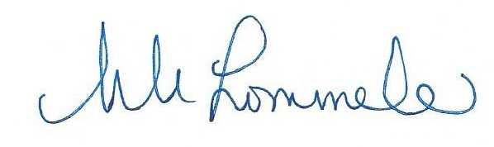

Morgan Lommele
Director of State & Local Policy
PeopleForBikes
P.O. Box 2359
Boulder, CO 80306
morgan@peopleforbikes.org
(720) 470-2981

Wash. Rev. Code 70.240.010(3)(b)(v) and O.R.S. 421A.253(3)(b)

