Installing the App in Mozu store:
Mozu will have to add our app to your store. Once that is done, go into the MozuAdmin -> Settings -> Applications. Click 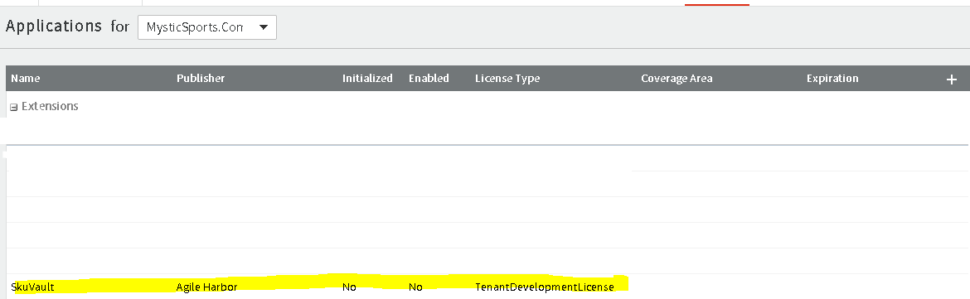
Click Enable App.
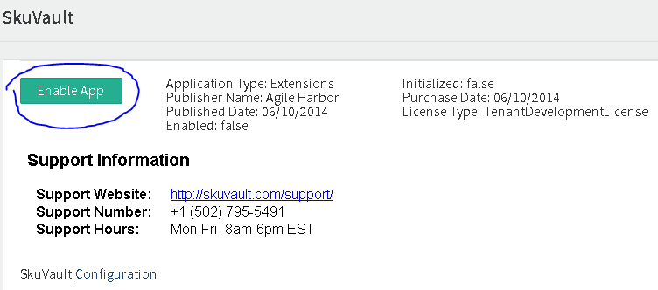
Our application name is SkuVault, namespace is agileharbor.skuvaultapp and application id is 3fd5d6e7e5ee4070b670a3340066de0d.
All inventory for sync should be in the 'Warehouse-01' location inside of Mozu.

Installing an app in SkuVault
Go to https://app.skuvault.com Login to your SkuVault account. Go to Admin->Channel Accounts. Create a new Mozu Channel Account. Enter your Mozu login credentials and click next:
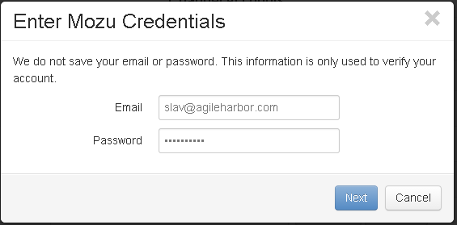
Choose your Store from the drop-down list. Then Choose Master Catalog from the drop-down list. Then choose Catalog. Then Choose Site. Then choose Location.
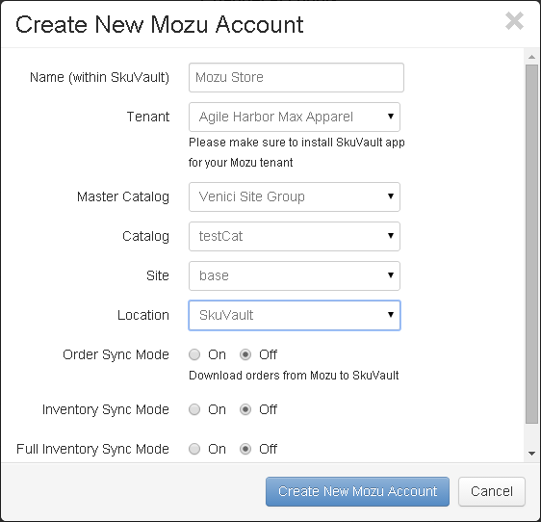

Enable any applicable syncs. Then click Create New Mozu Account.
