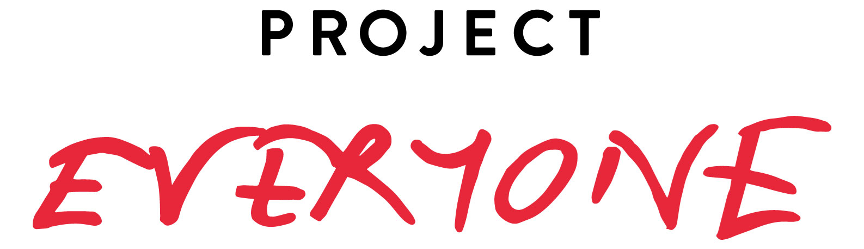
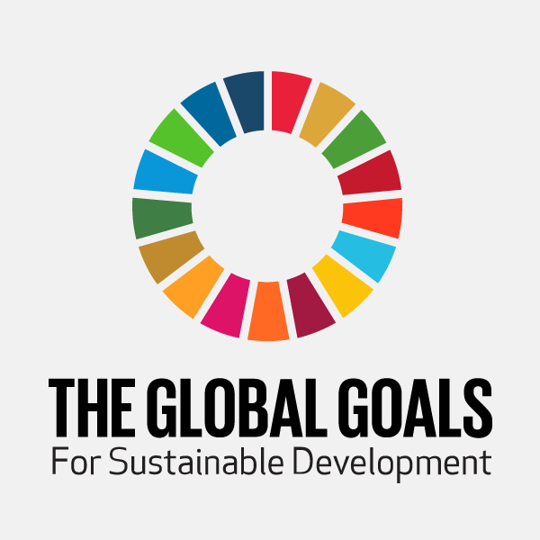

PRESS RELEASE, TUESDAY, 5TH JULY 2016:

GIRL POWER GOES GLOBAL FOR THE UN’S GLOBAL GOALS WITH NEW FILM #WHATIREALLYREALLYWANT:

20 years on, a remake of the Spice Girls’ Wannabe video, featuring artists from India, Nigeria, South Africa, UK, USA and Canada, tells world leaders what girls and women really really want in 2016 to achieve the Global Goals

- Project Everyone, in partnership with Getty Images and SAWA, the global cinema advertising association, release a new film “#WhatIReallyReallyWant” as part of the Global Goals campaign for girls and women.

- MJ Delaney of Moxie Pictures directs remake of the Spice Girls’ ‘Wannabe’ video, featuring artists from around the world including Gigi Lamayne and Moneoa from South Africa, Seyi Shay from Nigeria, Bollywood actress Jacqueline Fernandez from Sri Lanka, M.O from the UK, Taylor Hatala from Canada and Larsen Thompson from the USA.

- #WhatIReallyReallyWant launches online and in cinemas all over the world with a call to action for people everywhere to share a picture of #WhatIReallyReallyWant for girls and women. The responses will be shown when world leaders gather in New York this September for the UN General Assembly and the inaugural ‘Global Goals Week’.

In September 2016, World Leaders will mark the first anniversary of the adoption of the Sustainable Development Goals. These Global Goals are a mighty plan to end poverty, fix climate change and address inequalities over the next 15 years, but they will only succeed if they address the needs of the most marginalised first, particularly those of girls and women. Issues like quality education, an end to violence, an end to child marriage and equal pay for equal work need to be top of every governments’ agenda in order to give the Goals the best possible start.

Project Everyone, with partners from across the world, have convened the first Global Goals campaign to fight for Goals which are famous, financed and focused on girls and women. This week, on the 20th anniversary of the release of the Spice Girls’ Wannabe video, the campaign will mark twenty years of Girl Power with an updated version “#WhatIReallyReallyWant”. The film reflects the voices of girls and women all over the world telling world leaders what Goals they ‘really really want’ to be achieved to help improve their lives.

Speaking about the launch of the film, MJ Delaney, Director, said ‘This is about modern day Girl Power: The Spice Girls were about a group of different women joining together and being stronger through that bond, and these differences are what we want to celebrate in this film, while showing there are some universal things that all girls, everywhere, really really want.’

Victoria Beckham said, ‘I think this film is a wonderful idea. How fabulous it is that after 20 years, the legacy of the Spice Girls’ - 'Girl Power’ - is being used to encourage and empower a whole new generation.’

Richard Curtis, Writer, Director, Comic Relief Co-Founder & SDG Advocate said: ‘Last year the UN, Project Everyone and many partners launched a mass awareness-raising campaign reaching 3 billion people in just 7 days with news of the UN Sustainable Development Goals. This year we’re keeping up the noise and going deeper - fighting for 15 decisive years - trying to show how the Goals contain the answers to the world’s problems, from the refugee crisis to disease, humanitarian disasters to terrorism and war. And especially focusing on the incredible importance of progress in the area of girls and women - Global Goals for Global Girls.’

Bollywood actress Jacqueline Fernandez, originally from Sri Lanka said: ‘Gender discrimination has to stop and the global community has to start putting girls first. We need to create a community where girls feel strong, safe and supported and have equal access to education, technology, health and sanitation. What I really, really want is for people to recognize the potential of girls when they are allowed to study instead of doing household chores. And what I really, really want is to end violence against women. I want women to feel powerful and beautiful. Nothing can stop us once we are given equal opportunities and are allowed to flourish in a secure, supportive environment. The world needs a dose of girl power and that’s why I’m supporting the Global Goals campaign for girls and women.’

The film will be screened in SAWA member cinemas internationally between July and September 2016, distributed globally through Unique Digital, and will form part of a social media campaign calling on people to share a picture of #WhatIReallyReallyWant for girls and women. The visual responses from around the world will be presented to world leaders at the UN General Assembly in September to encourage new political and financial commitments from governments, in support of the Sustainable Development Goals.

The film #WhatIReallyReallyWant is online on Global Goals’ official YouTube channel. To access the YouTube link, click here:
https://www.youtube.com/watch?v=aQXSa-X4Bag&feature=youtu.be

The film will be shown in SAWA member cinemas internationally later in July.

ENDS

For further information, please contact:

Natasha Mudhar
Sterling Media
Tel: +44 20 7801 0077
Email: globalgoals@sterlingmedia.co.uk
Notes to Editors:

Global Goals Social Media Handles:

Hashtag: #WhatIReallyReallyWant
Facebook: https://www.facebook.com/globalgoals.org
Twitter: @theglobalgoals
YouTube: https://www.youtube.com/c/theglobalgoals
Instagram: https://www.instagram.com/theglobalgoals
Website: globalgoals.org

About Project Everyone & the Global Goals campaign
At the United Nations Sustainable Development Summit on 25 September 2015, 193 world leaders adopted a set of 17 Sustainable Development Goals. These ‘Global Goals’ are a plan of action to end poverty, combat climate change and fight injustice and inequality.

Project Everyone was devised by filmmaker and campaigner, Richard Curtis and founded by two women, Gail Gallie and Kate Garvey to make the Global Goals famous, so that they stand the greatest chance of being achieved - if people know about the Goals they can hold their governments, businesses and other institutions to account.

In the 7 days after world leaders formally agreed the Goals on 25th September 2015, it is estimated that news of the Global Goals reached 40% of the world’s population, which is over 3 billion people. Key drivers of this success were a text sent to 925 million people, radio programmes in 75 countries on 700 stations, millions of school children in 160 countries receiving a lesson on the goals and why they matter, a 1 hour TV programme shown in over 150 countries and homepage takeovers of Google, YouTube, Baidu, MSN, Bing and many others. There was significant advertising presence with 140,000 poster sites around the world, and a film shown in cinemas in 35 countries.

About the Global Goals campaign in 2016
In societies around the world, gender discrimination and inequitable gender norms are much more likely to limit girls’ ability to go to school, live free from violence, self-direct their life-course, and enjoy a level of social status and value equal as compared to their brothers and male peers.

A cursory glance of key indicators of well-being and freedom—from birth ratios to child marriage to sexual violence and the global HIV burden— clearly demonstrate that girls and women are disproportionately disadvantaged when it comes to gender equality.

There have never been more powerful advocates for women and girls, never been more campaigns fighting for women’s equality and there have never been more opportunities to fight for change as there are in 2016. The Global Goals campaign is providing a unifying, rallying call for commitments that will advance the health, wellbeing and rights of girls and women. Key progress has already been made this year with the announcement of UN Women’s HeForShe Impact Champions in Davos, where 10 of the world’s leading companies signed up to making gender equality an institutional priority, through to Melinda Gates’ announcement at Women Deliver Conference in May of the Bill and Melinda Gates Foundation's $80 million commitment towards gender equality efforts including closing the gender data gap. More announcements are expected at the UN General Assembly, the Global Fund Replenishment, Global Citizen Festival and International Day of the Girl Child. By the end of 2016, the first progress report on the Goals should be a series of commitments to Girls and Women.

The Global Goals campaign for girls and women was launched at the World Economic Forum in Davos this year, at a dinner attended by high profile advocates for the girls and women movement such as Melinda Gates, Sheryl Sandberg, Freida Pinto, Queen Rania of Jordan, Ngozi Okonjo – Iweala, Obiageli Ezekwesili, Bono, as well as NGOs and campaigns including Unicef’s Fight Unfair, ONE’s Poverty is Sexist, Global Citizen and Chime for Change.

www.globagoals.org www.project-everyone.org

About our Partners
We are grateful to our Founding Partners for making this project possible; Aviva, Bill & Melinda Gates Foundation, Getty Images, Pearson, SAWA, the global cinema advertising association and UNICEF.

