



# March 2018



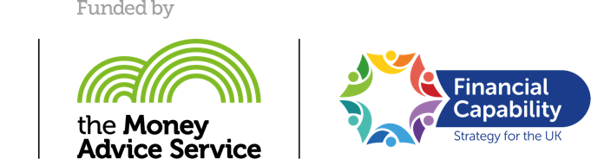

Contents

Executive Summary 1

Overview of Project 5

The Co-design Process 6

SaveStudySpend Theory of Change 7

Overview of the evaluation approach 8

Key Findings: Outcome Evaluation 12

Key Findings: Process Evaluation 24

Limitations of the evaluation and future evaluation 35

Implications and Recommendations for Policy and Practice 37

Sharing and Learning Activity 39

References 42

Get in touch 44

Appendix II: Process Evaluation Plan 45

Executive Summary

Summary of project

SaveStudySpend was a Scotland-wide, student-led investigation funded by the Money Advice Service and delivered by Young Scot to identify what financial capability support and interventions currently exist for further and higher education students across Scotland. This was a co-design project with young people playing a full role in all aspects of the project including planning, delivery and evaluation though membership of a Student Investigation Panel (SIP). The SIP researched what financial capability support services exist in Scotland for students, explored how these could be improved to create a bigger impact, examined what gaps exist and created solutions and recommendations on how these gaps could be addressed. SaveStudySpend ran from early 2017 to March 2018.

Summary of evaluation approach

Outcomes Evaluation

The outcomes evaluation aimed to measure the following Theory of Change outcomes:

1. Increased understanding of financial capability support available to students
2. More joined-up and enhanced financial capability support opportunities identified to meet students’ needs

The SIP investigation focussed on the following research questions:

1. What financial capability support and interventions currently exist for students across Scotland?
2. What gaps exist in provision and how can these be addressed?
3. How can services be joined up to create bigger impact to improve access to co-ordinated financial capability support for students in Further Education (FE) and Higher Education (HE) in Scotland?

The SIP gathered data through secondary research and six workshops with students.

Process Evaluation

The process evaluation of SaveStudySpend focused on the project itself and specifically the implementation of the project by the young people in the SIP. Data was collected from SIP members using pre and post online questionnaires and participative workshops. There were ten questionnaire responses at the start of the project and six at the end.

Summary of key findings:

* Half of all students were unaware of services in college or university that could help with money management or budgeting
* Financial capability support for FE and HE students in Scotland was provided on an institution-by-institution basis
* There was no consistent financial capability support provision in terms of access or quality
* Students often only accessed support when they were in crisis and needed to access emergency financial support through hardship funds
* Financial capability providers need knowledge of financial products and also the interpersonal, communication, and network skills to work with clients

Process evaluation findings

* Young people on the SIP had an improved understanding of financial capability
* Young people on the SIP developed new skills through participation in the project
* Young people on the SIP had a clear understanding of the use and provision of financial capability services
* Young people on the SIP generated ideas and solutions that reflect the reality of young people’s experience

Recommendations

1. Clearer financial capability information that is promoted to students effectively
2. Provide a minimum standard of financial capability support across Scotland
3. Instant access to jargon free support online and face-to-face
4. Flexibility and sensitivity in the financial support system
5. Provide advice on how to manage their money for the future and day to day
6. Financial capability support focussed on the need of the individual
7. Information and support to help with managing with rent, bills and other associated living costs
8. Low-income students made aware of the specific support available to them as individuals

Solutions

From the recommendations developed by the SIP, three ideas were developed to address the issues and gaps identified.

1. Myth busters – Short videos which aim to ‘bust the myths’ surrounding financial capability
2. Personal record for each student – A personal database record for students which would record all relevant information and circumstances of the individual students to enable better support
3. Financial capability workshops delivered at universities and colleges throughout Scotland.

Summary of methodological limitations

* The results from the workshops with young people are not necessarily replicable across every college or university across Scotland
* The project and evaluation design faced timing challenges and this needs to be considered in any other co-design projects with FE and HE
* Young people in a co-design project can be inexperienced in research. Young Scot mitigated this risk by providing training and support to the SIP and the secondary research the SIP gathered on financial capability provision in Scotland was based on published reputable research
* The evaluation approach cannot tell Young Scot whether the impact on the SIP members will be sustained
* Young Scot and the SIP do not know if the recommendations will be accepted by partners and therefore whether they will make a difference to young people

Summary of learning and sharing activity

* The SIP will present their recommendations and ideas into a report designed to be accessible by other young people and partners
* The report will also be hosted on the [www.youngscot.net](http://www.youngscot.net) website and highlighted in the Young Scot newsletter, YS Blether. Sign up to the newsletter here <https://www.youngscot.net>
* Young Scot will share the report with partners involved in the project to help them understand how their organisations and institutions can support students to be more financially capable
* Young Scot will share the report with the Money Advice Service Young Adult Steering Group
* The Young Scot Entitlement and Rewards team and Content Development team will use the report to better understand the information needs of students in relation to financial capability

Overview of Project

Young Scot’s previous engagement with young adults to understand their attitudes to credit and debt generally found that those transitioning from school into further and higher education had a lack of understanding and awareness of the financial support available to them. This then impacted on young adults’ ability to budget and manage their money effectively whilst at college or university. They were also typically unaware of sources of support and advice that they could access should they require financial assistance.

Through the What Works Fund with the Money Advice Service, Young Scot aimed to dig deeper into these issues by establishing a student-led investigation, which explored the following overarching question:

***How can financial capability support for FE and HE students in Scotland be joined-up and co-ordinated to improve access and creating bigger impact?***

In investigating this question, Young Scot also looked to explore the following sub-questions:

* What financial capability support and interventions currently exist for students across Scotland?
* What gaps exist in provision and how can these be addressed?
* How can services be joined up to create bigger impact to improve access to co-ordinated financial capability support for students in FE and HE in Scotland?

Young Scot recruited a group of young people between the ages of 17 and 23 from across Scotland, including Inverness, Aberdeen, Stirling, Dundee, Glasgow, Edinburgh and Fife, to form a Student Investigation Panel (SIP). The group was pulled together with a wide range of experiences and backgrounds, ensuring that the ideas and solutions developed would be appropriate and relevant, not only to the group members themselves but other students throughout Scotland. Although the group began with 15 members, due to the commitments of the participants it concluded with eight key members. As the target audience was specifically young people who were attending college or university, the level of time they could give as volunteers was understandably limited. This was mitigated throughout by continuous recruitment to top up numbers until the final phase of the project.  

The Co-design Process

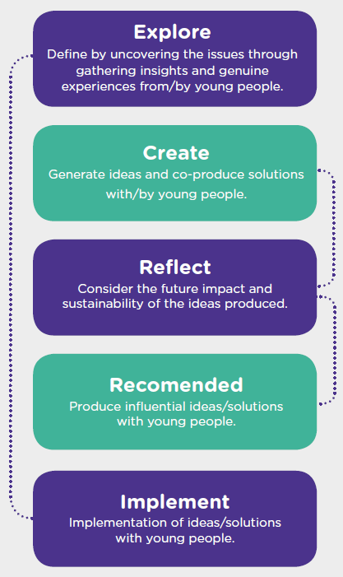Young Scot has extensive experience in engaging with Scotland’s young people to seek their views and input in the development of the services they use. Young Scot’s co-design process involves young people systematically creating, designing and delivering solutions. Supporting people to co-design ideas has been shown to have a radical impact on service innovation. Young Scot’s experience shows that using a co-design approach enables a more distributed, decentralised approach to innovation that supports Scotland’s ambitions to cede power and responsibility. This co-design process was used throughout the project to empower the young people involved in the SIP to develop informed ideas, recommendations and solutions for policy and practice. The process itself is based on design methodology and works through the five key phases: Explore, Create, Reflect, Recommend and Implement.

Throughout the ‘Explore’ phase the group developed a knowledge and understanding of the financial capability support available to FE and HE students in Scotland, by sharing their own experiences and their knowledge of the local support networks in the institutions they attend. This was expanded further through in-depth desk research, both of previous work that had been carried out relating to financial capability in Scotland and to develop a picture of students in FE and HE in Scotland.

The SIP’s initial ideas were tested with 80 students from North East Scotland College, to explore how a variety of students from different backgrounds may make use of the support available to them, as well as validating the new ideas from the SIP. This allowed the SIP to tailor the ideas and recommendations further to ensure they are relevant and appropriate for a wide variety of students.   The SIP would have liked to validate their ideas with students from other colleges and universities, but the academic timetable and project timescales meant this was not possible.

Although the SIP was able to test out their ideas with other students, this phase of the project was challenging. With the target audience they were looking to engage with and collaborate with, there are other vital commitments that demand their time, such as course work or employment, not to mention the social time which is a large part of their focus in this age and stage of life. The nature of how FE and HE institutions run meant there was no key time slot that would suit a multitude of students for an extended period of time. This meant that the SIP was unable to hold the large-scale testing events as initially planned, but adapted to hold small-scale events, allowing more quality time with the individuals involved.

There was an initial delay in the project start time due to project set up negotiations. This delay meant that recruitment started later than planned which pushed activity into the summer months when many of the students were not available or contactable through the partner institutions, this meant a lack of opportunity to engage with the target audience. There are few points in the year when students are available to engage in work out with their studies, so this was valuable time lost. Although the SIP were able to continue progressing the project, the planned ‘Innovation Lab’ events to test and validate ideas were delayed until the Christmas period. This delay made them impossible to organise with partner organisations and a series of small-scale events were held instead.

SaveStudySpend Theory of Change

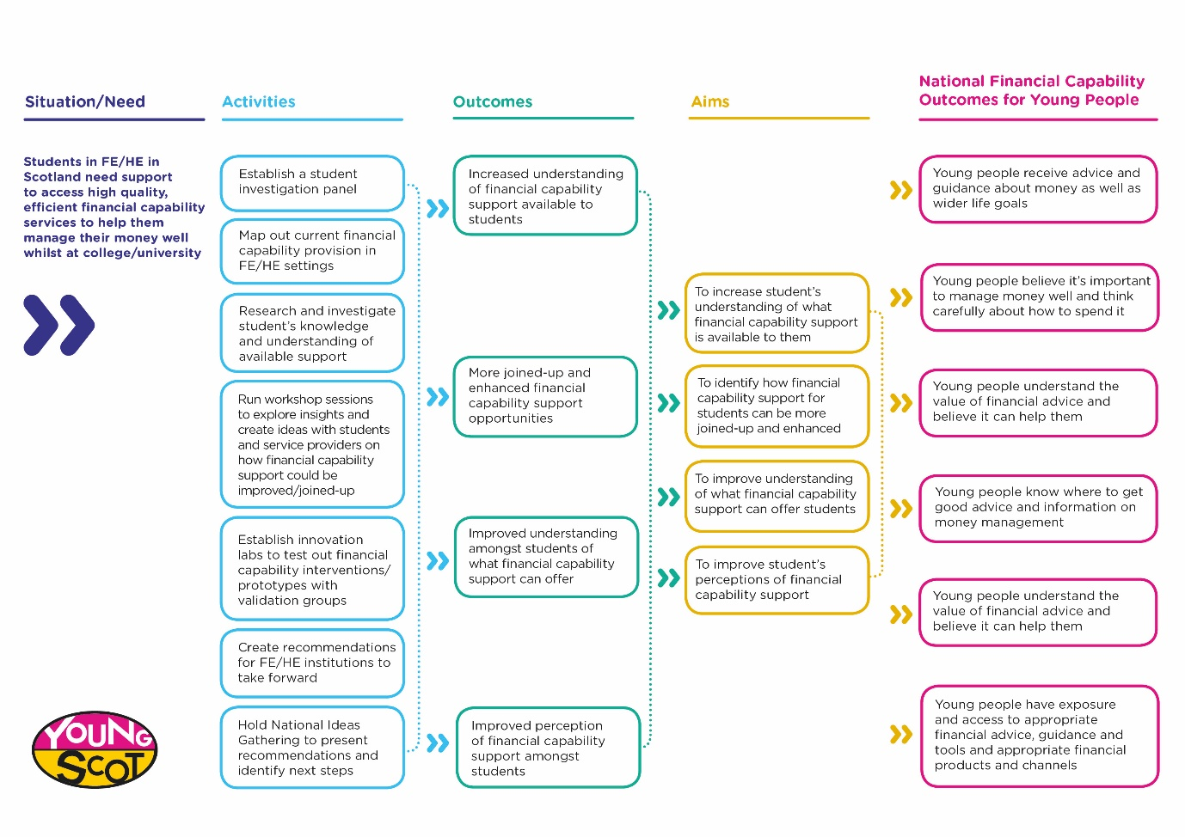

Overview of the evaluation approach

The SaveStudySpend project did not pilot a specific financial capability intervention with young people but rather aimed to support young people to conduct an investigation into what financial capability support services are available for students in Scotland.  The SaveStudySpend project engaged students through a co-design methodology to investigate the money-management issues that they and their student peers can face and to propose possible solutions. Working with stakeholders and young people to action the recommendations and solutions from SaveStudySpend project was out with the scope of this project.

The SaveStudySpend project contributes directly to the first two Theory of Change outcomes in the table below. The final two Theory of Change outcomes are dependent on the recommendations from SaveStudySpend being taken on board and implemented by the relevant stakeholders.The same is true of the Money Advice Service Outcome Framework Outcomes.  These are outcomes that the SIP and Young Scot would expect to see a positive impact in if financial capability services and support meet the needs of students in FE and HE consistently and effectively.

|  |  |
| --- | --- |
| **Theory of Change Outcome** | **Money Advice Service Outcomes Framework Outcome** |
| **Increased understanding of financial capability support available to students** | * Young people receive advice and guidance about money as well as wider life goals * Young people know where to get good advice and information on money management * Young people understand the value of financial advice and believe it can help them |
| **More joined-up and enhanced financial capability support opportunities identified to meet students’ needs** | * Young people have exposure and access to appropriate financial advice, guidance and tools and appropriate financial products and channels * Young people know where to get good advice and information on money management * Young people understand the value of financial advice and believe it can help them |
| **Improved understanding amongst students of what financial capability support can offer** | * Young people believe it’s important to manage money well and think carefully about how to spend it * Young people know where to get good advice and information on money management * Young people understand the value of financial advice and believe it can help them |
| **Improved perception of financial capability support amongst students** | * Young people believe it is important to manage money well and think carefully about how to spend it * Young people understand the value of financial advice and believe it can help them |

Evaluation of the SaveStudySpend project

The evaluation of the SaveStudySpend project was supported by Northern Star and had two key elements:

1. Process evaluation

The process evaluation of SaveStudySpend focused on the project itself and specifically the difference participation in the project made on the young people in the SIP and stakeholder organisations. Using the Theory of Change as a base, Northern Star worked with Young Scot project staff and young people to identify process specific outcomes and indicators. The outcomes identified the changes the project aimed to deliver, whilst the indicators outlined what to measure in order to understand the extent to which the project delivered on these outcomes.  The Process Evaluation Plan can be found in the Appendix of this report.  Specifically, the process evaluation focused on skills, knowledge, confidence and attitudes towards participation and service development and delivery.

All members of the SIP were sent a baseline and follow-up online questionnaire at the start and end of their engagement in the project respectively and invited to a participative workshop at each stage also.

During the project planning stage, it was envisaged that the SIP would work with stakeholder organisations, particularly colleges and universities in the innovation labs and national ideas gathering event, to gather data on their experience in the project using questionnaires and workshops.  By the time the young people were recruited to the SIP and the project progressed, it became difficult to engage with colleges and universities within the timescale available.

1. Outcomes evaluation

The outcomes evaluation focussed on the SaveStudySpend research questions:

* What financial capability support and interventions currently exist for students across Scotland?
* What gaps exist in provision and how can these be addressed?
* How can services be joined up to create bigger impact to improve access to co-ordinated financial capability support for students in FE and HE in Scotland?

The ‘Explore’ phase of the co-design process involved the SIP carrying out desk research to better understand the student support landscape in Scotland. The timing of the SaveStudySpend project coincided with a large-scale national survey of students conducted by YouGov for the Scottish Government-commissioned Independent Review of Student Financial Support in Scotland.  The following diagram shows a timeline of events from the independent review.

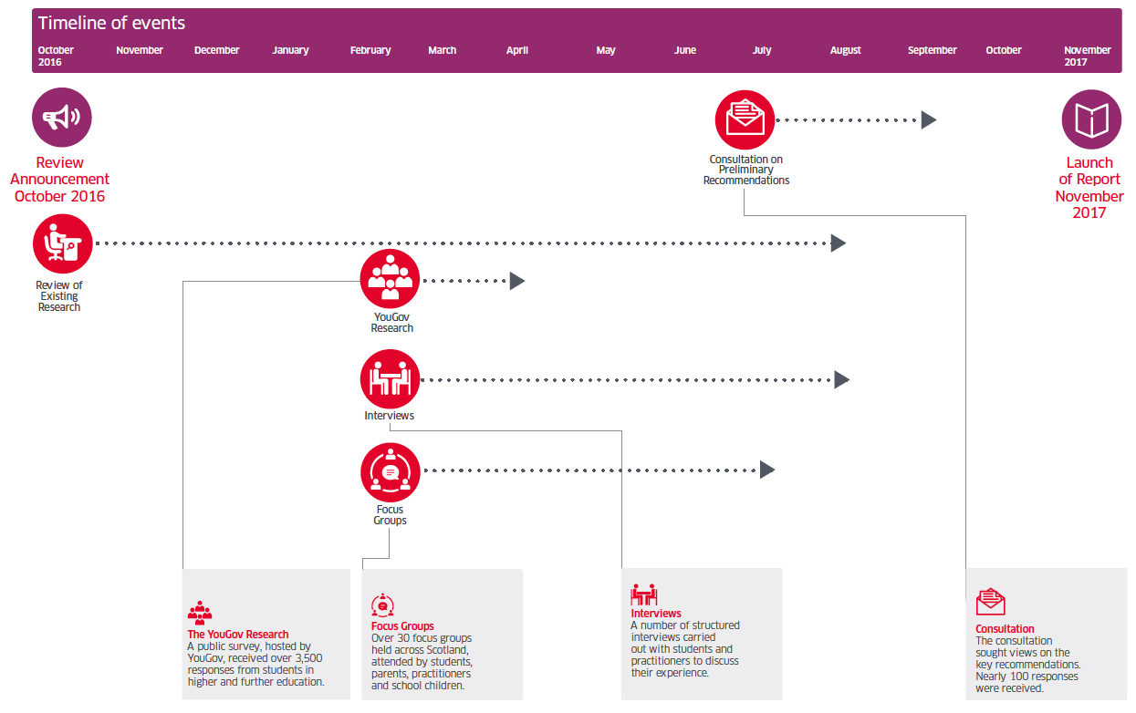

The Independent Review board included key stakeholders and the survey gathered 3,500 responses from students in FE and HE.  The SIP decided not to do their own survey of students given that it had already been conducted with a broader remit on a large scale by a professional research agency. The SIP focused its efforts into reviewing existing sources of information, including the survey, as well using as their own experience to build a picture of the financial capability support landscape.  Young Scot and Northern Star provided training for the SIP on secondary research, evaluating evidence and conducting primary research.

The original project proposal included a National Ideas Gathering event to share and develop ideas (with other young people and stakeholders).  Due to the delays in starting the project and the knock-on impact on recruitment of young people, the National Ideas Gathering event was removed from project activity.

In the ‘Create’ phase of the co-design process, the SIP used workshops with students to check whether their thinking and solutions were reflected in the lives of the student’s they spoke to.  The workshops engaged with 80 students and the results are included in the Key Findings section.

Key Findings: Outcome Evaluation

Research sub-question 1: What financial capability support and interventions currently exist for students across Scotland?

When the young people on the SIP began researching this question, they identified six specific questions they wanted to explore:

1. What is financial capability?
2. Who are students in Scotland?
3. What financial capability support is available?
4. How can you access that support?
5. Who is accessing financial capability support?
6. What financial capability challenges do students face?

They used a grid system to organise and categorise the information they found. A summary of findings is detailed below.

a) What is financial capability?

In their initial discussions on financial capability, the SIP focused on sources of income for students. The SIP explored and used three key definitions of financial capability through their research:

“People’s ability to manage money well, both day to day and through significant life events, and their ability to handle periods of financial difficulty” (Financial Capability Strategy for the UK, 2015)

“The system of financial advice, support and access for all students in further and higher education in Scotland” (Independent Review of Student Support in Scotland, 2017)

When somebody can effectively and confidently manage their finances and plan ahead; manage day to day finances; know where and how to seek advice and having motivation to effectively manage finances and adjust (Review of Financial Capability Training Resources, McQuaid and Egdell, 2011)

In the participative workshops with the North East Scotland College, some students were unsure of what financial capability meant and very few students talked about financial capability as knowing where to go for advice and support. Most students talked about financial capability as:

* “Having a budget, having savings, balancing incoming/outgoings and having a rainy-day fund”
* “Know how to manage with money”
* “Can support yourself and having money for emergency situations”
* “Being proactive and plan ahead. Always make a list and plan”
* “Being able to spend money when you want instead of worrying how much you have left”
* “To plan money for the month and still have left over to save and live comfortably”
* “I can afford everything I need, pay bills and have money for my hobbies”
* “Not being skint”
* “Being able to eat and sleep well and pay rent”
* “Being able to live a stable life money wise, the ability to save up, budget, handle bills and taxes with not too much stress and live a decent life”
* “Having control of my finances and budgeting well. Not going into debt”
* “To manage your money the best you can and to seek help if and when you need it”

The effects of poor financial capability were financial but also led to wider problems including debt, higher stress and reduced wellbeing (McQuaid and Egdell, 2011).

b) Who are students in Scotland?

Based on 2015/16 figures, there are 462,823 further and higher education students in Scotland.

**Higher Education[1]**

* 19 HE institutions in Scotland
* 235,565 students in HE institutions
* 76% were full time and 24% were part time
* 76% were undergraduates and 24% were postgraduates

**Further Education[2]**

* 26 colleges in 13 regions
* 227,258 students in FE institutions
* 19% of these students were studying at HE level
* 31% were full time and 69% part time
* Gender: 49% of students were male and 51% female
* Age: 10% of students were under 16 years old; 48% were aged 16 to 24; 42% were 25 years or older
* Disability: 19% of all learning hours were delivered to students requiring additional learning support
* Disability: 14% of students had a disclosed disability of which dyslexia was the most commonly reported (7% of disability)
* Ethnicity: 7% of all enrolments were students from minority ethnic backgrounds
* Widening access: 27% of school leavers went into further education; 23% of students studying higher education in colleges were from Scotland’s most deprived areas; 31% of full-time students were from Scotland’s most deprived areas; 90% of the growth in entry to university by disadvantaged students was through colleges

c) What financial capability support is available?

Each college or university provided a range of student support services and any financial capability support was decided and provided at an institution level. Financial capability support was often delivered by student support services. This offered the potential for targeted local support but there was no agreed consistent provision in terms of access or quality.

There was no agreement between colleges and universities about what constitutes financial capability support, so the support students could access was dependent on the college or university attended. The SIP discovered that often students only accessed support when they were in crisis and needed to access emergency financial support through for example hardship funds. They noted that this was often too late, and financial capability support would be better accessed before there was a problem. They also noted that students in crisis were not necessarily in the right frame of mind to be receptive to financial capability messages.

Financial capability was very often confused with provision of financial support in the form of grants, loans, bursaries or hardship funds. The SIP felt that both were important – improving financial support for students and improving financial capability support.

The Review of Financial Capability Training Resources (McQuaid and Egdell, 2011) that took place in 2011 identified that most financial capability support was delivered outside traditional money advice settings. Services were delivered in a wide variety of settings such as schools and community settings, and through a range of media - online, over the phone and face-to-face.

The review also identified the skills and knowledge that financial capability providers need. Providers needed knowledge of financial products and also the interpersonal, communication, and network skills to work with clients, such as:

* Knowledge of where to find information and resources
* Skills around budgeting and keeping track of expenditure
* Knowing when and where to refer users of their service to other organisations, as well as identifying any additional support needs that they may have
* Non‐financial skills, particularly interpersonal and communication skills

The YouGov Survey revealed some important data for SaveStudySpend:

* 80% of all students surveyed claimed at least one form of financial support
* Four in ten student said financial support was poor or very poor in meeting their needs
* Seven in ten students must supplement their financial support in other ways
* 14% topped up their finances with credit cards (9%) or other types of loans (5%)
* 27% of the lowest income students did not have the right information to help them apply for financial support
* Half of students who claimed financial support were very concerned about accumulating debt
* The three biggest expenses that financial support was used for were food (65%), rent (56%) and household bills (35%)
* 70% of students who claimed financial support said they had the right information to help them apply
* Three in five students thought that the information they received about the support they are entitled to was clear
* Only 56% of students who claimed financial support said that the process for applying was straightforward
* Although only a quarter of students received guidance from a funding adviser when they applied for funding, an overwhelming majority (92%) of recipients found that information to be important for accessing funding

d & e) How can you access that support and who is accessing it?

The key statistic from the YouGov research was that half (50%) of all students were unaware of services in college or university that could help with money management or budgeting. Of the 41% of students who were aware of services to help with money management or budgeting,[3] there was no publicly available information about how many of them accessed these services and how many accessed them when they were not experiencing difficulties compared with how many waited until crisis point. This data suggests that it was difficult for students to display financially capable behaviours when they are unaware of the services that can help them develop the ability and mindset to do so.

Other important data included:

* 13% of respondents to the YouGov survey did not claim financial support because they were not aware that any support is available
* Although students were very confident using online channels for information they were more likely to prefer face-to-face contact
* 51% of students did not feel confident in using a telephone method

In the workshops at North East Scotland College, each group was asked to discuss and note down what financial capability support services they have heard of and used. The number of young people who said they had used each of the services is displayed in the chart below. A total of 80 young people participated in the workshops.

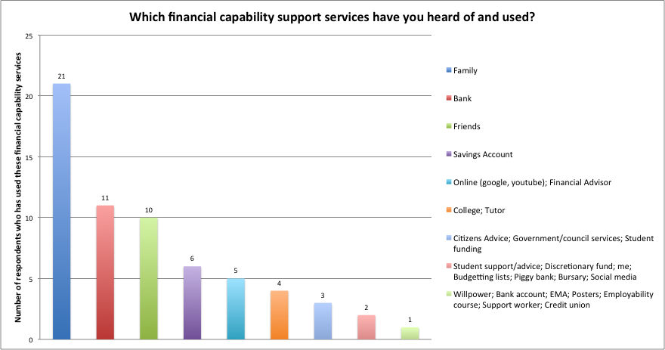

Family, their bank and friends were the most popular responses. Each group was asked about their experiences of accessing financial capability support. Across the six groups only seven individuals reported actively using financial capability support. The financial capability support they had accessed were:

* Citizens Advice
* College tutor
* Local council customer service team (3 people)
* Student funding team
* Money App

Their experiences of support were positive, and all bar one student would use those services again. Six out of seven students accessed this support when they were already experiencing financial difficulties.

f) What financial capability challenges do students face?

The SIP categorised the financial capability challenges students face into five key themes:

Financial capability services and information

The SIP found that there are already services being provided across the country, but students were not aware of the services available. The financial capability services provided varied between institutions. These services allowed students to reach their potential and provided fundamental support, particularly if a student was experiencing a personal crisis (for example, homelessness or lack of money to support themselves). The SIP thought that much of the information provided was not in a format that can be easily understood and was therefore not accessible to a variety of students. The level and quality of this information also varied between institutions, meaning students in one college or university may have had better or worse access to financial support than students in other institutions.

Food and Socialising

The SIP found that being on a tight budget meant that students did not always prioritise eating healthily and did not see it as a priority or possibility within their budget. The SIP thought this could have an impact on students’ learning but also on the way they socialised with their peers and the experiences they gained through their time at college or university.

Mental Health

Although mental health may not seem to have a link to the financial capability of students, the experiences and insights shared by the SIP demonstrated that stress and lack of support took a toll on their wellbeing. The SIP identified that students needed to be supported in a way that addressed their needs and personal situation, looking at them as a whole person and going beyond generic answers.

Bills and Livings Costs

Transitioning from living at home and being dependent on others, to managing your own money and expenses could be a stressful time for young people. With the stress of coursework, managing budgets often became less of a priority. Students often needed quick and simple advice on how to manage this without it requiring them to take time away from their coursework.

Low-Income Students

For some students studying in Scotland, loans or bursaries were be the only form of income they received. When the added pressure of a part time job or family life was considered, a number of students struggled to manage their income and expenditure. The SIP found that only 2% of students benefited from a lone parent grant, and a further 2% from disabled students allowance”[4] demonstrating that there may be a lack of awareness of the services and support available.

Research sub-question 2: What gaps exist in provision and how can these be addressed?

Research sub-question 3: How can services be joined up to create a bigger impact to improve access to co-ordinated financial capability support?

The SIP used the information they collated to explore research sub-questions 2 and 3. The SIP developed a series of ideas and recommendations to address the gaps and barriers identified for students in Scotland to access and make the most of the financial capability support available to them. The SIP identified from their own experiences and research five key themes that were vital in addressing these issues, with recommendations for each. These were: **Services and information; Food and Socialising; Mental Health; Bills and Livings Costs; and Low-Income Students**. They also identified key overall recommendations to address the barriers and gaps identified within the financial capability support services in Scotland.

Financial Capability Support

The Independent Review of Student Financial Support in Scotland found that “50% of students are unaware that university and college could provide help with money management or budgeting.”[5] This was echoed throughout the work of the SIP with very little knowledge of the information available and what was available was not relevant to their needs as a student. Providing clear and straightforward information to students, in a way that is relevant and engaging, would allow them to improve their money management ability, make informed decisions and make the most of the opportunities available to them.

**Recommendation 1**: **Clearer financial capability information that is promoted to students effectively**

The SIP’s own experiences and the research they conducted throughout the project showed there was an inconsistency across information services and support in Scotland both in college and universities. There is a need for a minimum standard of financial capability throughout FE and HE to ensure all students in Scotland are able to access and make the most of the opportunities available to them. This would also allow young people to transition from college to university more effectively, easing the stress of major life transitions for young people.

The SIP identified that communication between institutions needs to happen more effectively to create a minimum level of support that all students in Scotland have access to. Institutions should also make use of the tools available to them such as social media. By sharing information through a platform available to all students, creating links between institutions, it allows students to not only be more aware of what is available to them but can be the first step to them accessing effective support for their own personal situations.

**Recommendation 2: Provide a minimum standard of financial capability support across Scotland**

Independent Review of Student Financial Support in Scotland revealed that “51% of students did not feel confident in using a telephone method” and “Students are happy to use online services but prefer to use face-to-face methods of contact (39%)”[6]. This was echoed in the personal experiences of the SIP. Therefore, financial capability support needs to have the option of being provided face to face, in an easily accessed location that suits the timetable of students, such as after classes and lunch times.

**Recommendation 3: Instant access to jargon free support online and face-to-face**

The circumstances of each individual student can vary wildly, demonstrated within the SIP, so the support in place needs to have the flexibility to cater to a multitude of situations. This includes the support and advice given around financial capability but also the link to other support services, looking at the wellbeing of the individual as a whole. The SIP felt it was vital that those giving advice and support need to treat the students as individuals, understanding their personal situation and needs in a friendly manner

**Recommendation 4: Flexibility and sensitivity in the financial support system**

Food and Socialising

The Independent Review of Student Financial Support in Scotland found that: “The three biggest expenses that financial support is used for is food (65%), rent (56%), household bills (53%).”[7] The SIP thought that students needed more advice around how to make healthier and more affordable choices that can benefit their wellbeing, and to make the most of the discounts and offers that already exist. With better knowledge and understanding, students could be empowered to make informed decisions that will benefit them in the long-term. The SIP discovered a multitude of services and sources of advice and information for students around this, but the lack of awareness means they aren’t being used to their full advantage. Advice on making affordable and healthy choices would allow students to make the most of the opportunities available to them.

**Recommendation 5: Provide advice on how to manage their money for the future and day to day**

Mental Health

A ‘one size fits all’ approach did not suit most students and the system therefore needs to be flexible to suit their individual needs. This may mean accessing multiple services or support mechanisms to address the issues around financial capability, not just advice and information about how they can manage their money better.

The support provided to students needs to be flexible and adaptable to suit individual needs, not just moving the issue from one service to another but joining up services to better suit the needs of the individuals. Although there needs to be a minimum standard of advice and support, this should be elevated to specialist advice if needed.

**Recommendation 6: Financial capability support focussed on the need of the individual**

Bills and Living Costs

Many students found it difficult to manage bills and unexpected costs. Providing them with the knowledge and skills to plan for the future and manage their money effectively would allow them to not only make more informed choices, but also make them more resilient to cope with the unexpected.

**Recommendation 7: Information and support to help with managing with rent, bills and other associated living costs**

Low-Income Students

For low-income students it is vital they are aware of the support they are entitled to along with the care and advice in case their circumstances change, or they reach a crisis point. From the experiences of the SIP, it was difficult for some to share their personal circumstances with advisors they do not know, so information needs to be clear and accessible as the first point of contact.

**Recommendation 8: Low-income students made aware of the specific support available to them as individuals**

Solutions

The SIP developed three new ideas to address the issues and gaps identified.

Myth busters

Myth busters are short videos which aim to ‘bust the myths’ surrounding financial capability. An engaging video series targeted at students to inform them on various topics related to being smart with their money and making the most of what is available to them. Myth busters can be used as a starting point to inform students in an engaging way about the services already available to them.

Videos should be posted on various platforms, such as YouTube, Facebook and Snapchat and there should be some consideration for those who do not access social media. It is important to consider what platforms are widely used by students, making sure to engage where students already are rather than having to develop new touch points. Videos should be short, succinct, relevant and interesting. Advertisements on videos may not work as young people are likely to skip these, so they need to be integrated into channels already being used. Light-hearted tone and humour is vital to encourage young people to engage and should cover a variety of topics to cater for different circumstances.

Personal record for each student

A personal database record for students would record all relevant information and circumstances of individual students. By allowing support services access to their personal account, students can ensure they are getting holistic support, be it financial capability or mental health.

The SIP identified that specifically trained professionals should access and use the records. The SIP also recommended that thought is given to who else has access to the personal information stored and that it is secured under the relevant data protection law. Additionally, students should be given the option to decide whether they want their student account created or kept. The power should be in the hands of the individual student to make decisions and access support as they need it.

Workshops

Financial capability workshops delivered at universities and colleges throughout Scotland. These sessions should be fun yet informative and would provide students with the necessary information they need when it comes to managing their finances. During a student’s induction period at college or university they should partake in a mandatory workshop where they will develop an understanding of what it means to be financially capable and how to manage their money. It is recommended that the frequency of workshops is set to common pressure points during the academic year - the start and end of semesters, exam periods etc., focusing on the tough periods for the majority of students.

Workshops must be interactive to engage students in a relevant way to them and must involve professionals to inspire trust and confidence, for daily money management as well as long-term goals and consequences.

Key Findings: Process Evaluation

The process evaluation focused on the difference the project made on the young people who were members of the SIP.

Using the Theory of Change as a base, Northern Star worked with Young Scot project staff and young people to identify process specific outcomes and indicators. The outcomes identified the changes the project aims to deliver, whilst the indicators outlined what to measure in order to understand the extent to which the project delivered on these outcomes. The process evaluation outcomes, indicators and data collection methods are detailed in the Process Evaluation Plan in the Appendix. Specifically, the process evaluation focused on skills, knowledge, confidence and attitudes towards participation and service development and delivery.

The process evaluation gathered data from SIP members at the beginning of their involvement in the project (May-June 2017) and at the end of the project (March 2018). Data was gathered through an online questionnaire and participative workshops. There were ten questionnaire responses gathered at the start of the project and six at the end. The baseline data helped project staff to understand the support and training needs of the young people who were involved.

As SaveStudySpend progressed, the Young Scot project team faced two major challenges. The learning from these challenges is detailed below:

1. Project timescales and the academic timetable

As described earlier in the report, the delays to the project starting led to delays in recruitment and planned project activity. This had a significant impact on project activity, probably more so than in other co-design projects due to the educational timetable the project needed to fit within. A longer project development time would have enabled Young Scot to involve colleges and universities right at the planning stage which might have mitigated some of the timing challenges. When a project is based within education, the academic timetable is a critical consideration. It significantly affects the ability of organisations to work with colleges, universities and students and for this reason it is important that projects take account of this, start on time and allow enough leeway in project plans to account for possible delays.

In the future, funders and organisations developing projects that engage students or educational institutions need to consider the following in project planning:

* The academic timetable and key times of the year when it is difficult to deliver projects – exam time, holidays etc.
* A longer project development and delivery time
* Developing projects in partnership with educational institutions so they are key stakeholders at the planning stage and the delivery stage

2. Young people on the SIP

The late start of SaveStudySpend not only delayed activity but pushed recruitment of young people to the SIP into exam and holiday periods. Young Scot found it more challenging than they anticipated to recruit young people to the panel.

A total of 20 young people were involved in the SIP throughout the project. Some young people joined at the start of the project and left before the end; some young people joined after the start of the project and some young people joined at the start and were still involved at the end. The fact that young people recruited to the SIP did not remain constant throughout the project brought both challenges and opportunities. Young people joining the SIP after the start brought fresh perspectives to the SIP’s work but that also meant that the SIP had to revisit previous work so could not progress as quickly.

Based on Young Scot’s co-design experience, some change in the makeup of the panel was expected. Young people involved in the project were volunteers who were either at college or university and some also had part time jobs. The main reason for young people leaving the project was a difficulty in managing a demanding academic workload, paid employment and their volunteer commitments. In future projects this needs to be factored into the project planning and recruitment to ensure that a young person’s financial situation is not a barrier for their participation.

Findings

This final report only includes data from young people who were actively involved at the end of the project. There was a total of 8 young people involved in the final stages of the project and of these young people:

* 6 completed a baseline questionnaire
* 7 completed a follow up questionnaire
* 3 were involved in the initial participative workshop at the start of the project
* 8 were involved in the follow up workshop at the end of the project

This report is structured around those outcomes and indicators identified in the Process Evaluation Plan

About the SIP members

Only three members of the SIP had been involved in previous Young Scot projects. That most of the panel were new to the co-design approach was a positive in that Young Scot were recruiting from a wide range of young people and experience rather than relying on a small group of young people.

The SIP members were asked why they decided to join the SaveStudySpend project and their responses fell into three main categories:

1. To help others - SIP members were motivated to participate in the project by a desire to help other students and ensure that student’s voices are heard on this issue
2. Personal experience of student finance – motivation to join the project was driven by personal experience and relevance to their life as a student
3. To develop skills/knowledge – SIP members also wanted to better their own ability to manage their money, expand their knowledge and develop a range of skills.

Process Outcome 1: Young people involved in the SIP develop their knowledge, skills and confidence

Indicator 1.1 Young people have an improved understanding of financial capability

The Financial Capability Strategy for the UK defines financial capability as:

“People’s ability to manage money well, both day to day and through significant life events, and their ability to handle periods of financial difficulty.”[8]

The Strategy focuses on developing people’s financial skills and knowledge, and their attitudes and motivation.

Northern Star asked SIP members what ‘financial capability’ meant to them. Initially SIP members said that financial capability means being able to manage money and being financially independent by not relying on family for money. For a couple of SIP members, it also meant understanding what support is available and where to go for help. However, early SIP discussions focussed on financial capability for students as sources of income such as loans, grants, bursaries and hardships. By the end of the project, young people on the SIP thought they had a broader understanding of financial capability. They reflected that they had previously thought of financial capability as knowing where to go for sources of income or not spending money but now recognised that it involves skills, knowledge and attitudes towards money.

“I realised financial capability isn't about how much money you have, but how you make the most with what you do have” (SIP member)

“I also misunderstood financial capability partially with knowledge of sources of finance and not management” (SIP member)

“I've learnt that just by setting things out a little bit clearer or making a wee note of what’s coming out, I'm not as stressed. So, I've learnt how to actually move that stress away…I know after all that’s gone, I've got this to play with, or I can plan for that unexpected event that I might not have been able to a few months ago.” (SIP member)

SIP members thought financial capability was really important for young people. They described how becoming a student involved greater financial independence and that students need the knowledge and skills to manage this independence.

“As students we need all the support we can get, and knowing where you can get it or who can help you is really important” (SIP member)

They discussed how attending college or university brought its own specific spending needs (usually on course related books and equipment) and this also increased pressure on students’ finances. They thought that an inability to manage money could have a significant impact on their educational achievements.

“It is important to budget spending wisely when you are a student. Loosing track of your finance may significantly impact on your education or future” (SIP member)

Indicator 1.2 Young people identify the new skills they have developed

In the baseline participative workshops, the SIP members identified the knowledge and skills they thought they would need during the SaveStudySpend project. These could be skills or areas of knowledge that they already had but needed to develop further or entirely new skills or areas of knowledge. In the baseline and follow up questionnaires SIP members rated themselves for each one. The table below shows the change between baseline and follow up of positive ratings (summing the responses for *I’m excellent at this* with *I’m very good at this*). The skills are ordered from biggest to smallest change during the project.

|  |  |  |  |
| --- | --- | --- | --- |
| Skills/Area of knowledge | Number of SIP members with positive rating at the baseline | Number of SIP members with positive rating at the follow up | Change |
| Digital skills - using social media, the internet, apps etc | 5 | 7 | 2 |
| Team work | 5 | 7 | 2 |
| Persuading others | 3 | 5 | 2 |
| Research skills - gathering data | 3 | 5 | 2 |
| Problem solving | 5 | 6 | 1 |
| Communication skills | 5 | 6 | 1 |
| Organisation skills | 5 | 6 | 1 |
| Time management | 4 | 5 | 1 |
| Public speaking | 3 | 4 | 1 |
| Networking | 4 | 5 | 1 |
| Research skills - analysing data | 3 | 4 | 1 |
| Writing reports | 3 | 4 | 1 |
| Handling conflict in a group | 5 | 5 | 0 |
| Leadership | 5 | 5 | 0 |
| Making change | 5 | 5 | 0 |
| Engaging with young people | 6 | 5 | -1 |

Almost all SIP members reported that they were excellent or very good at digital skills and team work by the end of the project and these were two skills that saw the biggest change. This is perhaps unsurprising given the nature of the project. The SIP was a diverse range of young people involved who worked closely together and used a range of digital tools for research and communication such as Basecamp, Facebook, WhatsApp, internet search etc. SaveStudySpend also helped SIP members to be better at persuading people and gathering data. In the workshops, SIP members talked about the importance of using evidence from their research to make their case and back up their recommendations.

SIP members in the workshops also reported that their data and problem-solving skills had improved though participation in the project and identified peer support as important improving their skills and tackling challenges.

“You know, I think we’ve all been quite good at noticing when each other struggles. We’ve identified our strengths and weaknesses within each other, and we’re not afraid to kind of praise the positives but support each other when we need it.” (SIP member)

The SIP highlighted the variety of practical tools and methods such as ‘the Anti-Problem’ [9]or ‘100 Ways to Squeeze a Lemon’ [10]that Young Scot had introduced which had helped them to improve their problem-solving skills. They were also able to reflect on how the tools and methods they had used in the project had been useful in other areas of their lives, from helping to improve other organisations they were involved with to thinking about college work. Three members of the SIP highlighted that their public communication skills had improved and that this was making an impact on their studies at college and university, volunteering and employment.

“I think communication is the biggest one for me too because it was one of the things I hoped to achieve out of the project, and I think I did because the atmosphere here was so good that I was more confident in speaking out and just putting my opinions through and helped me doing teamwork at college. Now, I speak out loud a bit more.” (SIP member)

Members of the SIP explained how during the project, all members had been given the opportunity to lead within the project.

“Young Scot projects are quite good for getting everyone to be involved”. (SIP member)

During the follow-up workshop, the SIP identified two skills that they felt they had developed during the project that did not feature in the list above - budgeting skills and working independently.

Financial Capability of SIP members

In the follow up workshop, over half of the SIP (5 out of 8 members) felt that their budgeting skills had improved. Northern Star used questions from the Financial Capability Strategy for the UK’s Children, Young People and Parents Outcome Framework to understand the SIP’s level of financial capability.

More than half of SIP members who responded to the baseline questionnaire (5 out of 6 respondents) said that they made a plan of how they spend and save their money. There was no change in this by the follow up questionnaires where 5 out of 7 respondents said they made a plan. At the follow up, of those that did make a plan, 2 members kept to their plan *sometimes* whilst 3 members *often* stuck to their plan.

All members of the SIP kept track of their spending and saving using a variety of online and offline tools. The chart below shows the change in how SIP members kept track of their money between the baseline and follow up.

The biggest change was in the number of SIP members who kept track of their money in their heads which may be linked to increased awareness of the importance of budgeting that was reported by SIP members.

As a result of SaveStudySpend, SIP members were more aware of the financial capability support that was available as well as where and when to go for help.

“And now I’m kind of more aware that they’re actually there, which is a help, you know… So, no, I’m kind of aware that it’s actually there before I get into financial trouble.” (SIP member)

“I’ve learned how to budget, I’ve learned how to just look for information and be able to… I feel a bit more confident in my skills to do financial capability and my own financial capability. So, it’s the most… almost the most real project I’ve been on, which has been beneficial.” (SIP member)

Indicator 1.4 Young people report an increase in confidence as a result of their involvement in SaveStudySpend

In order to measure young people’s confidence and communication skills at the baseline and follow up, young people were asked in the questionnaires how much they agreed or disagreed with a series of five statements:

* I am confident to say what I think
* I am able to listen to other people's opinions
* I am confident to question other people's opinions
* I am willing to change my own opinion if I hear someone else's views
* I see things from other people's point of view

Between the baseline and follow up there was a positive change in the number of panel members who ‘really agreed’ that they were able to listen to other people’s opinions (from two to five) and see things from other people’s point of view (from one to three). SIP members reported that the group really respected one another’s opinions and that Young Scot staff did the same. Young people felt listened to and that their opinions and ideas were acted upon

At the follow up SIP members were able to explain how the confidence they had developed through the project was helping them in other areas of their lives.

“All through my high school time, my teachers always said, you're just lack the confidence, and you don’t like believe in yourself, which I said, yeah, probably. But I’d say this project has definitely helped that. (SIP member)

“Like for exams and uni work and stuff, I need to just like… I… I’m more like, you can do this now. Be confident in yourself.” (SIP member)

Process Outcome 2. Young people create and influence financial capability policy and services

Indicator 2.1 young people have a clear understanding of the use and provision of financial capability services

Indicator 2.2 young people generate ideas and solutions that reflect the reality of young people’s experience

Indicator 2.3 young people generate ideas and solutions that take into account the future sustainability and need

At the outset, members of the SIP had an understanding of the use and provision of financial capability services from their own experience and perspective. Through their research, they developed a Scotland-wide understanding of the broader context. As detailed in the *Key Findings – Outcome Evaluation* section of this report, the SIP established an understanding of what financial capability support and interventions currently exist for students across Scotland and where they thought the gaps in provision were. They worked with over 80 young people to sense-check their thinking and ensure that their recommendations were reflective of the reality of young people’s experience.

In the follow up workshop, the SIP members were clear that the recommendations they developed were underpinned by evidence, anchored in the reality of young people’s lives and offered a range of possible solutions including some ‘quick wins’ for colleges and universities.

The discussions with the SIP as part of the follow up workshop revealed that members of the SIP felt real ownership of the recommendations and thought that the project was genuinely youth-led.

“…here and with the team we’ve got, you know, everything we do we can claim. We can see it in a final report and go, I've said that, or we did that, or that group supported that.” (SIP member)

The SIP would have liked a clearer sense of purpose for their work at the start of the project which might have helped them work quicker in the initial stages, but they also really valued the genuine power shift and transfer of control that the project had given.

“The co-design team understands kind of how young people work best, like it’s not tokenistic... it’s just the whole kind of set up of how they do stuff works because they work with young people, they kind of want to understand young people” (SIP member)

Stakeholders

Due to the way the project progressed, there was a much lower level of engagement with stakeholder organisations than was envisaged in the original project proposal. In order to implement the SIPs recommendations there will need to be systematic engagement with organisations such as government, colleges, universities and student support services. This implementation is beyond the scope of the SaveStudySpend project. Young Scot will share the SIP’s final recommendations Scottish Government and policy makers, as well as key stakeholders in FE and HE institutions.

Limitations of the evaluation and future evaluation

The SaveStudySpend project with its co-design ethos empowered young people in FE and HE in Scotland to conduct their own investigation into what financial capability services and support were available for students, in order to make recommendations about how to improve those services.  The recommendations developed by the SIP were grounded in published secondary research and the reality of young people’s lives.

There are some methodological challenges posed by this approach.  Young people can be inexperienced in research, which can affect the quality of the research.  Young Scot mitigated this risk by providing training and support to the SIP, and the secondary research the SIP gathered on financial capability provision in Scotland was based on published reputable research. The structured and tested co-design approach also added rigour to the process.  The SIP investigating an issue that affected them directly gave them an insight that would have been difficult to gain otherwise.

The workshops with young people in North East College Scotland engaged with over 80 students in six workshops.  These workshops were helpful for the SIP to test their thinking and ideas but, given the relatively small numbers of young people engaged relative to the Scottish population as a whole, the data from these workshops is not replicable across every college or university across Scotland.

The project and evaluation design faced timing challenges, and this needs to be considered in any other co-design projects with FE and HE.  The academic timetable does not have lots of space where students have time to engage significantly with projects and project planning needs to be mindful of key pressure points during the year such as exam time.

The evaluation approach used to understand the impact on the SIP members was appropriate for the project, but it cannot be said whether the impact on the SIP members will be sustained.  Learning from other co-design projects Young Scot has delivered suggests that impact from volunteering in co-design projects is sustained and young people often go on to volunteer on other projects.

The SaveStudySpend project aimed to research and develop recommendations for financial capability support within FE and HE in Scotland. Working with FE, HE and other stakeholders to implement these recommendations is beyond the scope of this project and as such there is no way of understanding at this stage whether these recommendations have been accepted and have made a difference.  Whilst Young Scot will continue to use the SIP’s recommendations to work with partners to improve financial capability services and support there are no plans to continue evaluating the work of this project.

Implications and Recommendations for Policy and Practice

The SIP developed the following recommendations and solutions to address the gaps and barriers identified for students in Scotland to access and make the most of the financial capability support available to them.

Recommendations

Recommendation 1: Clearer financial capability information that is promoted to students effectively

Recommendation 2: Provide a minimum standard of financial capability support across Scotland

Recommendation 3: Instant access to jargon free support online and face-to-face

Recommendation 4: Flexibility and sensitivity in the financial support system

Recommendation 5: Provide advice on how to manage their money for the future and day to day

Recommendation 6: Financial capability support focussed on the need of the individual

Recommendation 7: Information and support to help with managing with rent, bills and other associated living costs

Recommendation 8: Low-income students made aware of the specific support available to them as individuals

Solutions

The SIP developed three new ideas to address the issues and gaps identified:

Myth busters

Myth busters are short videos which aim to ‘bust the myths’ surrounding financial capability.

Personal record for each student

A personal database record for students would record all relevant information and circumstances of individual students. By allowing support services access to their personal account, students can ensure they are getting holistic support, be it financial capability or mental health.

Workshops

Financial capability workshops delivered at universities and colleges throughout Scotland. These sessions should be fun yet informative and would provide students with the necessary information they need when it comes to managing their finances.

The SIP developed these solutions and recommendation and SIP members would make use of these services and look for financial capability support and as such they are more relevant and attuned to the needs of the target audience. Although engaging with the target audience of 16+ students in Scotland can mean competing with other commitments and priorities, these ideas if implemented and further developed are designed to fit in with the lives of students already, building an awareness of services as well as improving services and allowing students in Scotland to make the most of the opportunities available to them. As these ideas have been developed and co-designed by students, in order to scale up and develop them and ensuring they are sustainable solutions, they must be implemented in collaboration with students. This will allow for further development that is relevant and appropriate for the target audience.

The report from Independent Review of Student Support, *A New Social Contract for Scotland’s Students*, makes a number of recommendations that overlap with the SIP’s recommendations, in particular the recommendations around parity and clarity:

|  |  |
| --- | --- |
| *A New Social Contract for Scotland’s Students[11]* | Link to SIP Recommendations |
| “A single, centralised online portal to provide information to all students” | Recommendation 2: Provide a minimum standard of financial capability support across Scotland |
| “Consistent guidance and communications for prospective students of all ages, parents and carers” | * Recommendation 1: Clearer financial capability information that is promoted to students effectively * Recommendation 3: Instant access to jargon free support online and face-to-face * Recommendation 5: Provide advice on how to manage their money for the future and day to day * Recommendation 7: Information and support to help with managing with rent, bills and other associated living costs * Recommendation 8: Low-income students made aware of the specific support available to them as individuals |
| “Local support system to help students navigate the system, especially those with more specialist needs” | * Recommendation 3: Instant access to jargon free support online and face-to-face * Recommendation 4: Flexibility and sensitivity in the financial support system * Recommendation 6: Financial capability support focussed on the need of the individual * Recommendation 7: Information and support to help with managing with rent, bills and other associated living costs * Recommendation 8: Low-income students made aware of the specific support available to them as individuals |
| “Common funding system across further and higher education, with local face to face support” | * Recommendation 2: Provide a minimum standard of financial capability support across Scotland * Recommendation 3: Instant access to jargon free support online and face-to-face * Recommendation 8: Low-income students made aware of the specific support available to them as individuals |

The synergy between the SIP’s recommendations and the recommendations from *A New Social Contract for Scotland’s Students,* means that any piloting or implementation needs to engage Scottish Government as well colleges, universities and student support services. The recommendations from the SIP add weight to the call from *A New Social Contract for Scotland’s Students* to improve the parity and clarity of support for students. As detailed in the following section, Young Scot will share the recommendations with key stakeholders in Scotland and use the recommendations within Young Scot’s own information services for young people. More extensive piloting or implementation is beyond the scope of this project.

Sharing and Learning Activity

Existing Sharing and Learning Activity

Throughout the project Young Scot carried out a series of sharing and learning activities, to allow partners and young people to hear more about the work being delivered.

For the launch of the ‘SaveStudySpend’ project, a press release was sent out through the www.youngscot.net platform. This was shared with partner organisations to keep them up to date with the work Young Scot carry out with young people in Scotland but also to allow partners to express an interest in getting involved throughout the project.

The opportunity to get involved in the project was also shared through the young.scot platform (<https://young.scot>), which holds information and opportunities for young people across Scotland to allow young people to apply to volunteer as part of the project.

For the launch of Scottish Financial Capability Week, Young Scot attended and shared the progress of the project along with many members of the Money Advice Service Young Adults Steering Group. This allowed other partners in the sector to hear more about how Young Scot are engaging with students across Scotland and the financial capability support available to them. This also provided a further network for sharing the final report and findings in the future.

Future Sharing and Learning Activity

The SIP will pull their recommendations and ideas into report designed to be accessible by other young people as well as partners throughout the financial capability community in Scotland.

The report will be shared through a variety of platforms:

* Young Scot will produce a press release which will be shared with local partners though our Localities Managers. This will allow local partners throughout FE and HE organisations to make use of the recommendations and ideas developed by the SIP
* The report will also be hosted on the [www.youngscot.net](http://www.youngscot.net) platform to allow any partners working with young people to learn from the process and to understand what approaches work when designing and developing financial capability services for young people
* Young Scot also distributes a regular newsletter (accessed via www.youngscot.net) in which a link to the report will be included
* The partners specifically involved in the SaveStudySpend project, as well as FE and HE key support officers, will be able to make use of the findings in the final report to understand how their organisations and institutions can support students to be more financially capable through the services they are already providing
* As Young Scot sits on the Money Advice Service Young Adult Steering Group, the final report and SIP report can be shared through this group to allow other organisations in the financial capability community and support services in Scotland, to learn from and make use of the findings
* Young Scot will share the recommendations of the SIP report with Scottish Government and policy makers to ensure those working on delivering recommendations from A New Social Contract for Scotland’s Students and developing policy throughout Scotland are able to make use of the learning and recommendations
* Within Young Scot itself the final report will be shared with other teams to make use of the results. The Entitlement and Rewards team will be able to better understand how the Young Scot card and its related services can be strengthened to support the financial capability of students. The Content Development team will better understand the information needs of students in relation to financial capability so Young Scot can strengthen the information content provided on our digital platform and via social media channels

References

Colleges Scotland (2017) *Key Facts*. Available from <https://collegesscotland.ac.uk/briefings-and-publications/publications/1115-colleges-scotland-keyfacts-2017-final-web-version/file>

Independent Review of Student Support in Scotland (2017) *A New Social Contract for Students* available from <http://www.gov.scot/Resource/0052/00527875.pdf>

McQuaid, R and Egdell, V (2011) *Review of Financial Capability Training Resources*, Edinburgh Napier University for Scottish Government

Money Advice Service (2015) *Financial Capability Strategy for the UK.* Available from <http://www.fincap.org.uk/uk_strategy>

# Money Advice Service (2017) *MAS Financial Capability of Children Young People and their Parents in the UK* available from <https://www.moneyadviceservice.org.uk/en/corporate/research>

NUS Scotland (2011) *Breaking the Silence* available from <https://www.nus.org.uk/Documents/NUS%20Scotland/Breaking%20The%20Silence.pdf>

SAAS (2016*) Higher Education Student Support in Scotland 2015-16* available from <http://www.saas.gov.uk/_forms/statistics_1516.pdf>

YouGov (2017) *Student support review: Topline report for the Scottish Government* available from <http://www.gov.scot/Resource/0052/00527879.pdf>

Websites

<http://www.bbc.co.uk/news/uk-scotland-38599150>

<https://beta.gov.scot/policies/universities/student-financial-support/>

<https://www.citizensadvice.org.uk/scotland/family/education/further-and-higher-education-s/the-discretionary-fund-s/>

<https://www.ed.ac.uk/studying/international/finance/cost-of-living>

<http://www.erasmusprogramme.com/the_erasmus.php>

<https://www.expatistan.com/cost-of-living/dundee>

<https://www.expatistan.com/cost-of-living/edinburgh>

<http://www.gcu.ac.uk/student/money/managingyourmoney/costofliving/>

<https://www.hesa.ac.uk/data-and-analysis/students>

<https://www.kingdomfm.co.uk/news/local-news/edinburgh-least-affordable-for-students/>

<https://www.mygov.scot/student-discounts/>

<http://personal.rbs.co.uk/personal/life-moments/student-living-index.html>

<https://professionals.carers.org/sites/default/files/supporting_student_carers_fe.pdf>

[www.saas.gov.uk](http://www.saas.gov.uk)

<https://www.savethestudent.org/money/student-money-survey-2016.html#budget>

<http://www.scottishwideraccess.org/national-about-swap>

<https://www.skillsdevelopmentscotland.co.uk/publications-statistics/statistics/participation-measure/?page=1&statisticCategoryId=7&order=date-desc>

<https://www.theeducator.com/news/edinburgh-students-face-highest-costs-spend/>

<https://www.theguardian.com/education/2017/aug/23/young-carers-suffering-in-silence-university-support>

Get in touch......



Or pop in for a cuppa and a hobnob…

We are happy to consider requests for this document to be produced in other languages or formats.

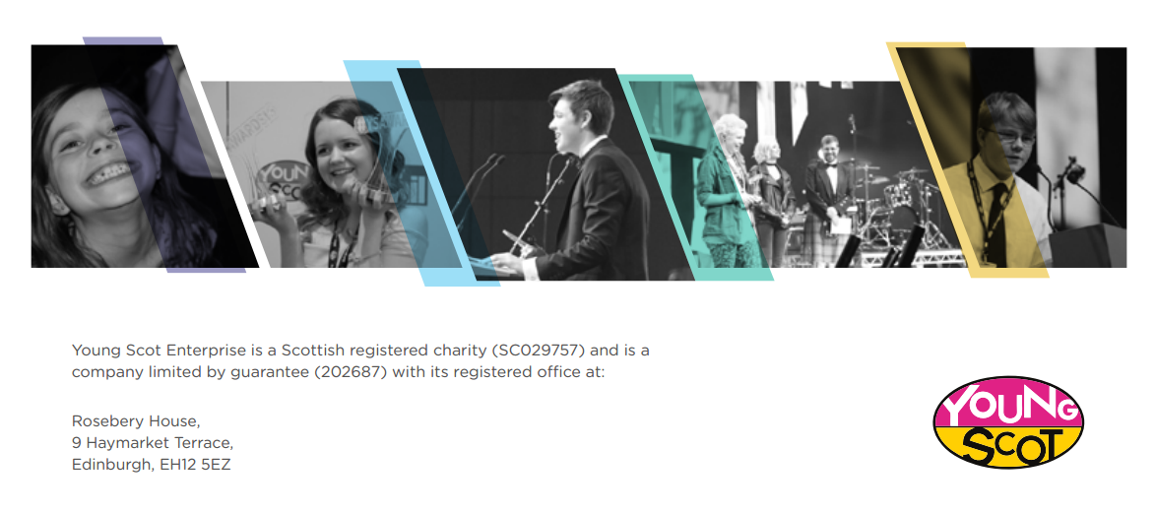

# 

Appendix: Process Evaluation Plan

SaveStudySpend

Process Evaluation Plan

SaveStudySpend was a Scotland-wide, student-led investigation to identify what financial capability support and interventions currently exist for students across Scotland, how these could be potentially joined up to create bigger impact, looking at what gaps exist and creating solutions and recommendations on how these gaps could be addressed. This was a co-design project with young people playing a full role in all aspects of the project including planning, delivery and evaluation.

Evaluation of the SaveStudySpend project had two key elements:

Process evaluation

The process evaluation of SaveStudySpend focused on the project itself and specifically the implementation of the project. Using the project Theory of Change, project staff and young people identified specific outcomes and indicators for the process evaluation. These outcomes and indicators are detailed in the plan below and linked to the overall Theory of Change for the project.

Outcomes evaluation

The outcomes evaluation focused on understanding what works and assessing progress against Theory of Change outcomes. The outcomes evaluation was designed and delivered in partnership with the SIP as part of the overall co-design process.

The process evaluation plan used Young Scot’s evaluation framework, National Youth Work Outcomes and indicators and the Financial Capability Outcomes Framework for Children, Young People and Parents.

|  |  |  |  |  |
| --- | --- | --- | --- | --- |
| Process Evaluation Outcome (the change or difference you wanted to make) | Indicators (what did success look like? how did you know the outcome was happening) | How did you collect the information | When did you collect the information? | |
| 1. Young people involved in the SIP develop their knowledge, skills and confidence  This process evaluation outcome contributes to the following Theory of  Change outcomes:   * Increased understanding of financial capability support available to students * Improved understanding amongst students of what financial capability support can offer * Improved perception of financial capability support amongst students | 1.1 Young people have an improved understanding of financial capability | Questionnaire – Baseline at the start of the project and follow up at the end of the project  Workshop - Baseline at the start of the project and follow up at the end of the project | Baseline - May/June 2017  Follow up – February 2018 | |
|  | 1.2 Young people identify the new skills they have developed  (Experience from previous co-design projects suggests that young people can expect to develop the following skills:   * Communication skills including public speaking * Influencing and negotiation skills * Team work * Research * Information Literacy * Digital skills) | | Questionnaire – Baseline at the start of the project and follow up at the end of the project  Workshop - Baseline at the start of the project and follow up at the end of the project | Baseline - May/June 2017  Follow up – February 2018 |
| 1.3 Young people use the knowledge, skills and confidence developed in a different setting | | Questionnaire – follow up at the end of the project  Workshop - follow up at the end of the project | Follow up – February 2018 |
| 1.4 Young people report an increase in confidence as a result of their involvement in SSS | | Questionnaire – Baseline at the start of the project and follow up at the end of the project  Workshop - Baseline at the start of the project and follow up at the end of the project | Baseline - May/June 2017  Follow up – February 2018 |

|  |  |  |  |
| --- | --- | --- | --- |
| Process Evaluation Outcome (the change or difference you wanted to make) | Indicators (what did success look like? how did you know the outcome was happening) | How did you collect the information | When did you collect the information? |
| 2. Young people create and influence financial capability policy and services  **This process evaluation outcome contributes to the following Theory of Change outcomes:**  **More joined up and enhanced financial capability support opportunities** | 2.1 young people have a clear understanding of the use and provision of financial capability services  Analysis of SIP research and outputs  Workshops – baseline and follow up | Analysis of SIP research and outputs  Workshops – baseline and follow up | February 18  Baseline - May/June 2017  Follow up – February 2018 |
| 2.2 Young people generate ideas and solutions that reflect the reality of young people’s experience  Analysis of SIP proposals and outputs | Analysis of SIP proposals and outputs  Workshops – follow up | February 18  February 18 |
| 2.3 Young people generate ideas and solutions that consider the future sustainability and need | Analysis of SIP proposals and outputs  Workshops – follow up | February 18  February 18 |

|  |  |  |  |
| --- | --- | --- | --- |
| Process Evaluation Outcome (the change or difference you wanted to make) | Indicators (what did success look like? how did you know the outcome was happening) | How did you collect the information | When did you collect the information? |
| 3. Stakeholder organisations work in partnership with young people  **This process evaluation outcome contributes to the following Theory of Change outcomes:**  **More joined up and enhanced financial capability support opportunities** | 3.1 Stakeholder organisations have developed a deeper understanding of financial capability service provision and accessibility from a young person’s perspective | Stakeholder questionnaire at the end of the project  Workshop - follow up at the end of the project | February 2018  February 18 |
| 3.2 Stakeholder organisations have considered and provided feedback on the views and ideas of young people | Stakeholder questionnaire – follow up at the end of the project  Workshop - follow up at the end of the project  Project Documents | February 18  February 18  February 18 |
| 3.3 Stakeholders have built a relationship with and developed an understanding of ways young people can be involved | Stakeholder questionnaire – follow up at the end of the project  Workshop - follow up at the end of the project  Young people’s questionnaire – follow up | February 18  February 18  February 18 |
| 3.4 Stakeholders value the participation of young people in policy and service development | Stakeholder questionnaire – follow up at the end of the project  Workshop - follow up at the end of the project | Follow up – February 2018  February 18 |

1. <https://www.hesa.ac.uk/data-and-analysis/students>
2. Colleges Scotland (2017) *Key Facts*. Available from <https://collegesscotland.ac.uk/briefings-and-publications/publications/1115-colleges-scotland-keyfacts-2017-final-web-version/file>
3. In addition to the 50% of students unaware and 41% of students aware, 9% did not know.
4. Scottish Government[Online] *Independent Review of Student Financial Support in Scotland,* Published 20 November 2017 Available at: <http://www.gov.scot/Publications/2017/11/3884/0>
5. Scottish Government[Online] *Independent Review of Student Financial Support in Scotland,* Published 20 November 2017 Available at: <http://www.gov.scot/Publications/2017/11/3884/0>
6. Scottish Government[Online] *Independent Review of Student Financial Support in Scotland,* Published 20 November 2017 Available at: <http://www.gov.scot/Publications/2017/11/3884/0>
7. Scottish Government[Online] *Independent Review of Student Financial Support in Scotland,* Published 20 November 2017 Available at: <http://www.gov.scot/Publications/2017/11/3884/0>
8. Money Advice Service. 2017. *Financial Capability Strategy for the UK*. [ONLINE] Available at: <https://prismic-io.s3.amazonaws.com/fincap-two%2Fd176f87b-48f9-4344-9d26-afc4df5d86f5_uk+financial+capability+strategy.pdf>. [Accessed 17 August 2017].
9. The “Anti-Problem” - In this activity, participants are asked to identify ways to solve the problem opposite to their current problem. The purpose is to get people to evaluate a problem from a different perspective and discover things that they are doing that are contributing to the actual problem.
10. “100 ways to Squeeze a Lemon” - This task is used in the design industry, focusing on creating quick sketches or descriptions of 100 ideas, in order to produce a wider variety of solutions in quick succession, in a fixed amount of time.
11. Independent Review of Student Support in Scotland (2017) *A New Social Contract for Students*