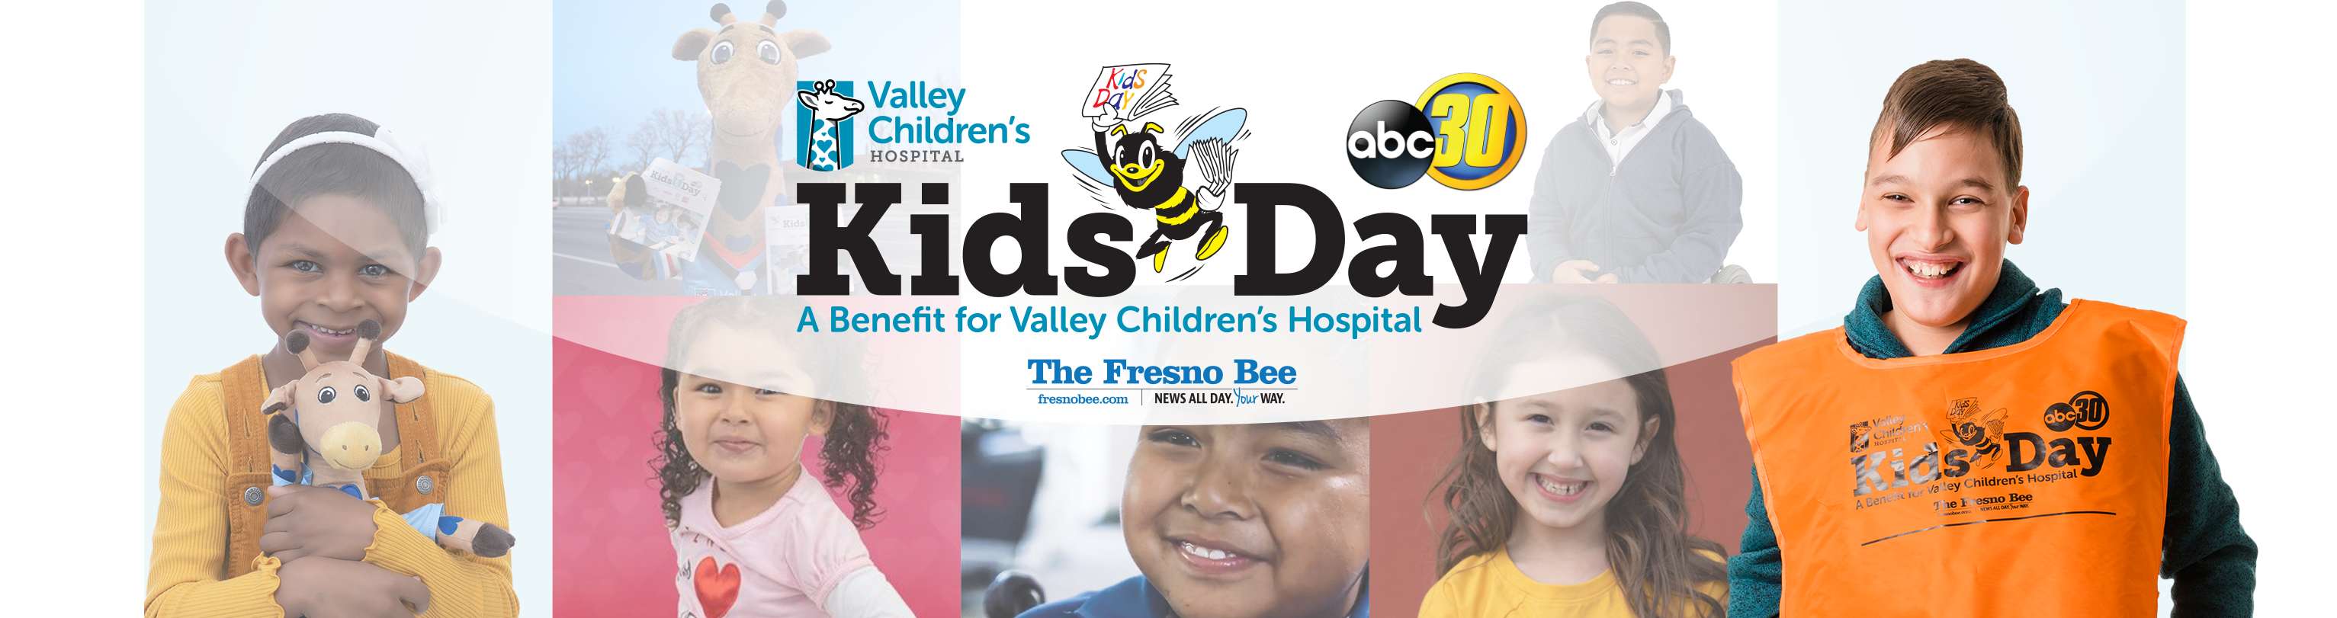

Dear [NAME],

This March, I am participating in Valley Children’s Hospital’s 36th annual Kids Day. As one of the largest fundraising events in the Central Valley, Kids Day hosts more than 20 communities who come together to raise funds that support the ill and injured children of the Central Valley.

This year, Valley Children’s will provide care for one in every nine children in a service area with more than 1.3 million children. I am participating in Kids Day to help ensure that they all have access to quality and life-saving healthcare right here in the Central Valley.

I would greatly appreciate your support of Kids Day this year by donating through my Kids Day fundraising page, which can be found here: [NSERT LINK TO YOUR PAGE]. My goal this year is to raise a total of [$ ENTER FUNDRAISING GOAL]. Any amount you can donate will make a huge difference!

Thank you so much for your consideration.

Sincerely,

[YOUR NAME]